# **Task2 Documentation**

VXD240002, Dacharla Venkata Abhiram

## Introduction

I successfully completed Task2 by creating a web interface (task2.php) that allows full CRUD (Create, Read, Update, Delete) operations on the course database created in Task1. This documentation outlines the implementation details and functionality of this task.

## Project Setup

I created a /cs6314/task2 folder in the htdocs directory. Within this folder, I created:

* task2.php: The main PHP file that displays the table and provides CRUD functionality
* js folder: Contains testcases.js, the JavaScript file for test cases
* task1.sql: Output that we got by running task1.html

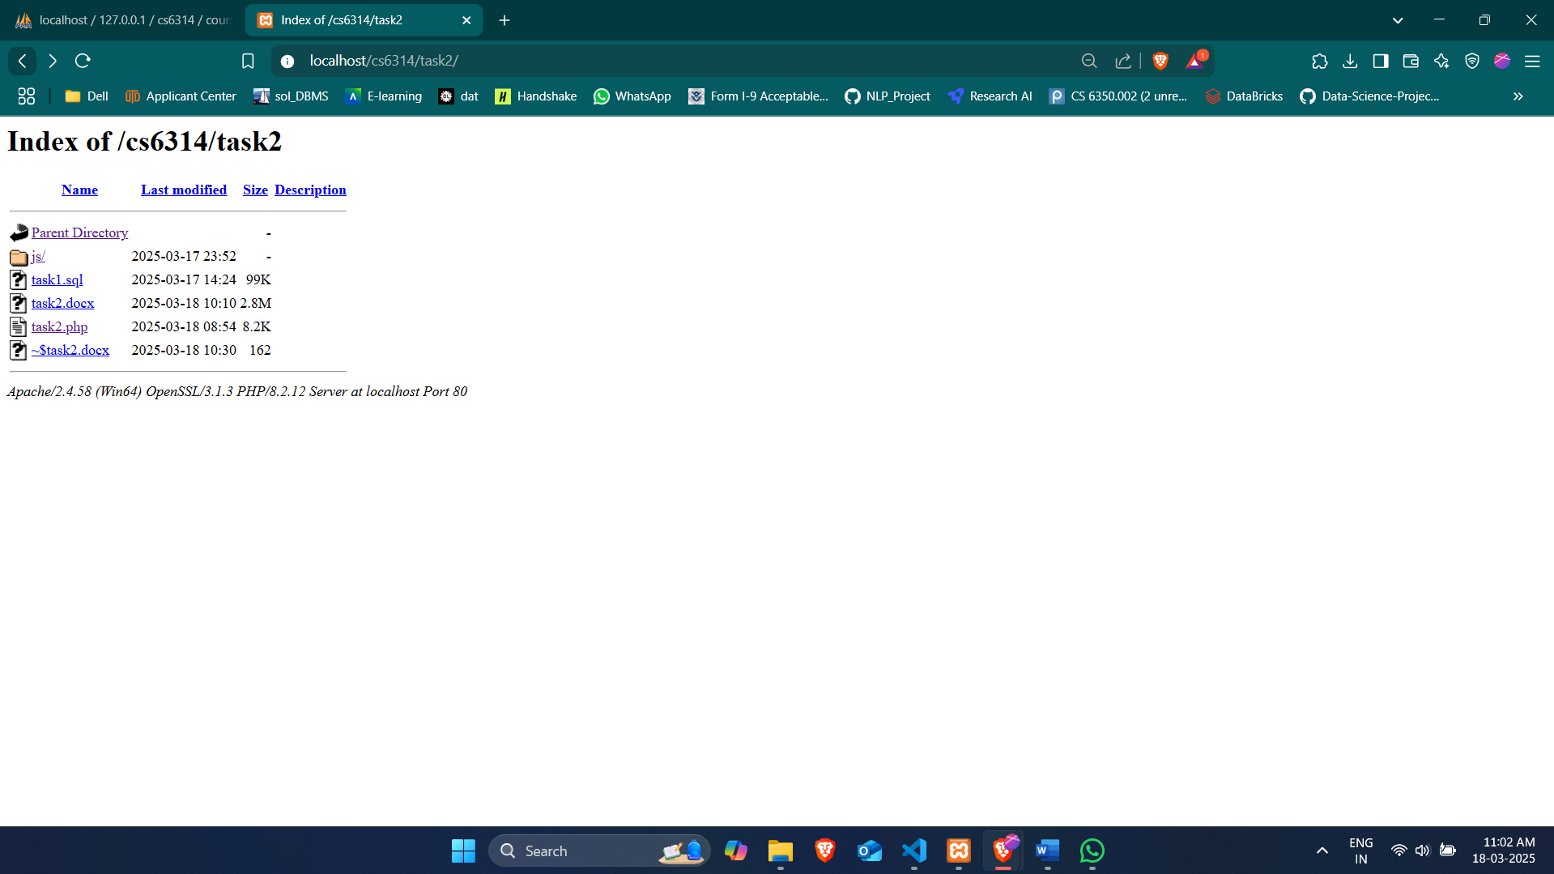

## Implementation Details

## Database Connection

The script establishes a connection to the MySQL database using the following details:

* Server: 127.0.0.1 (local XAMPP server)
* Username: root (default XAMPP username)
* Password: (empty, default XAMPP password)
* Database: cs6314

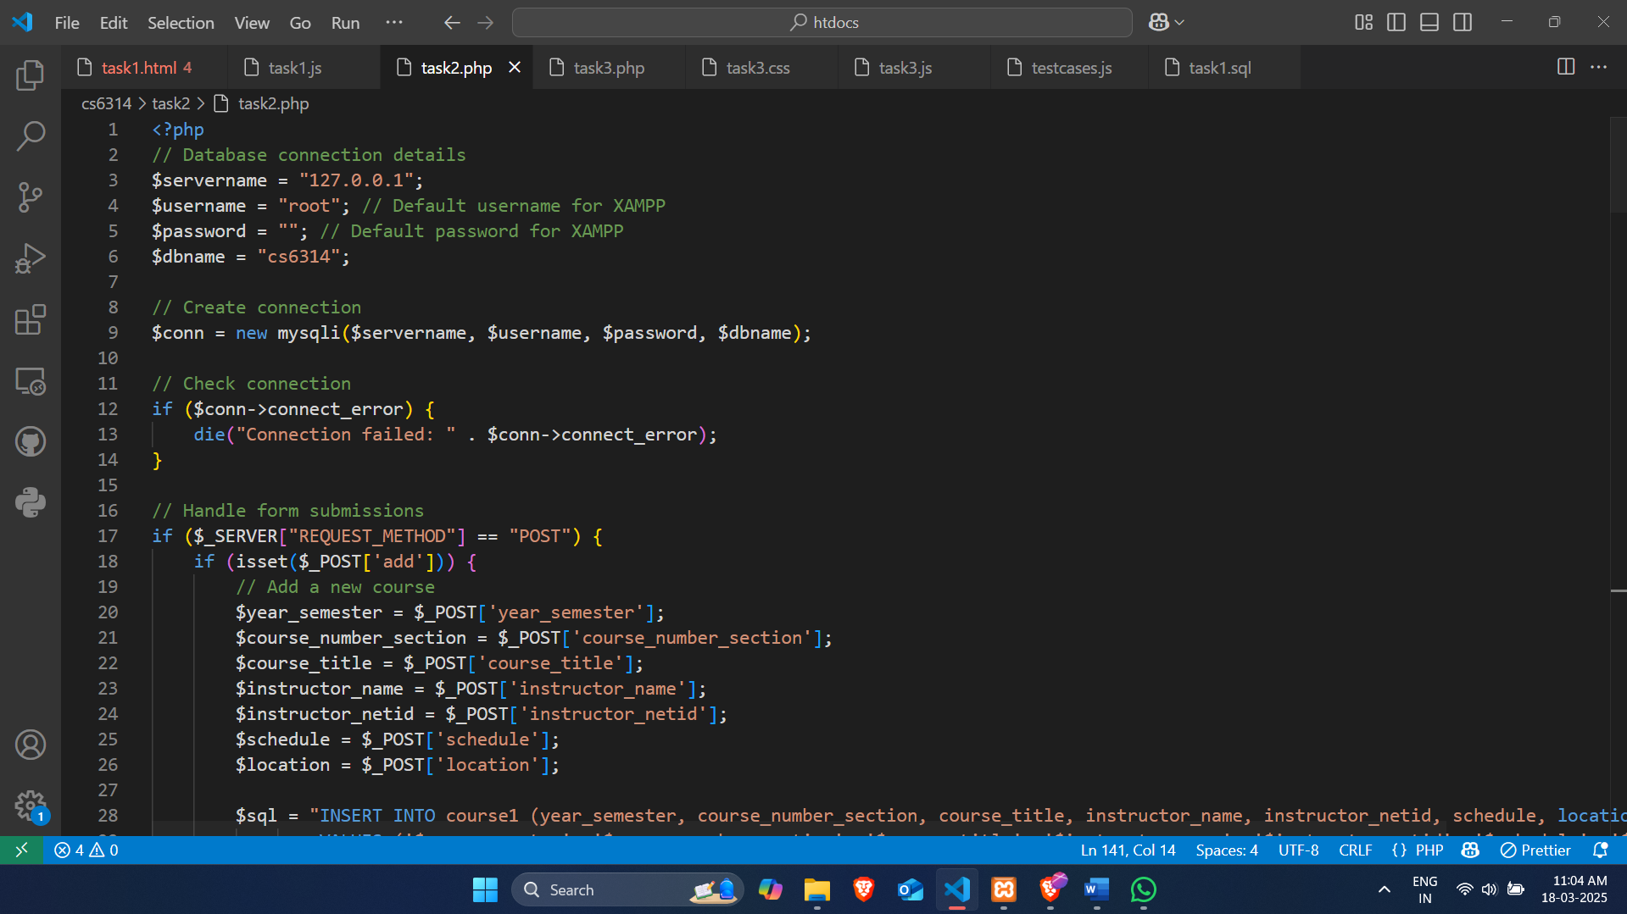

## Form Handling

The script handles three types of form submissions:

* Adding a new course
* Updating an existing course
* Deleting a course

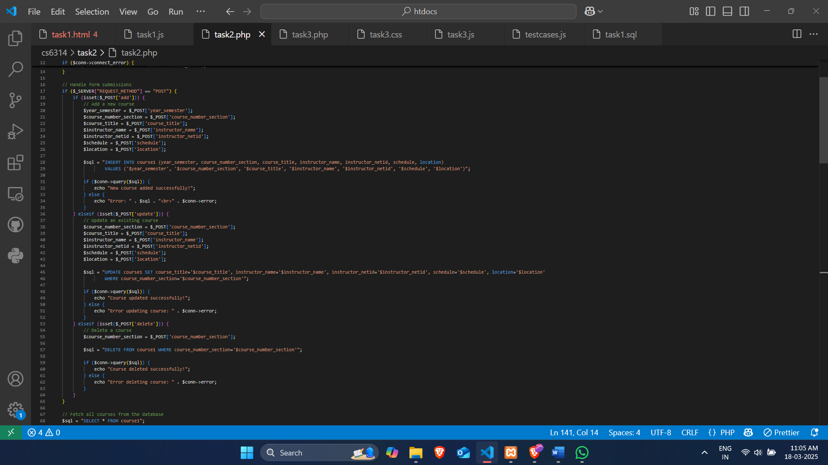

## Course Display

The script retrieves all courses from the "course1" table and displays them in a formatted table with action buttons for updating and deleting.

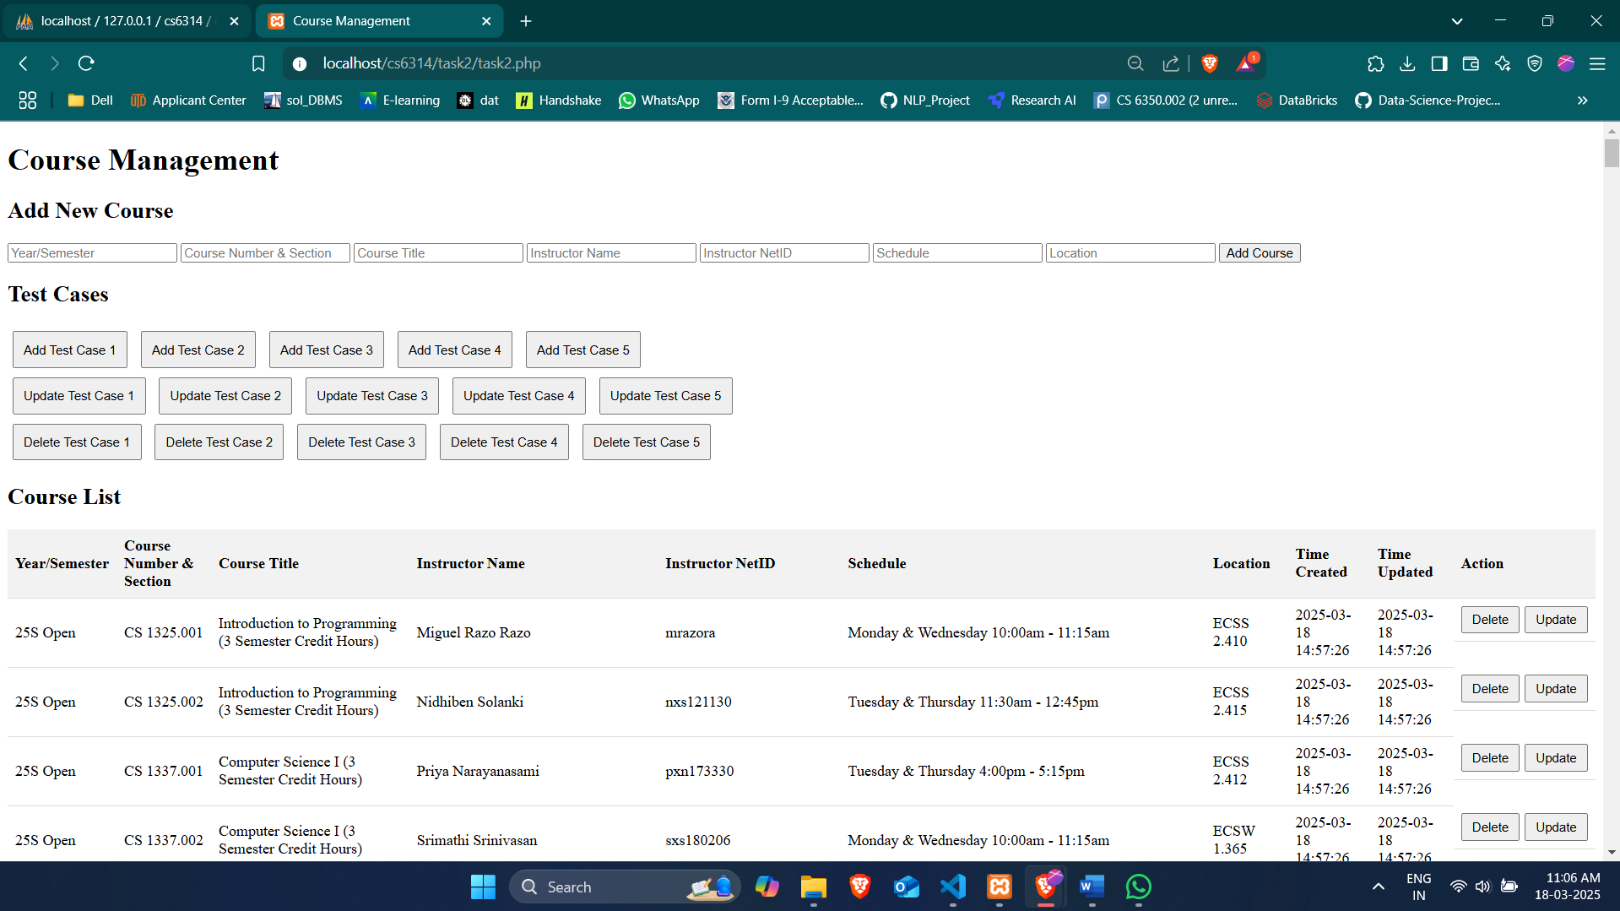

Bottom part

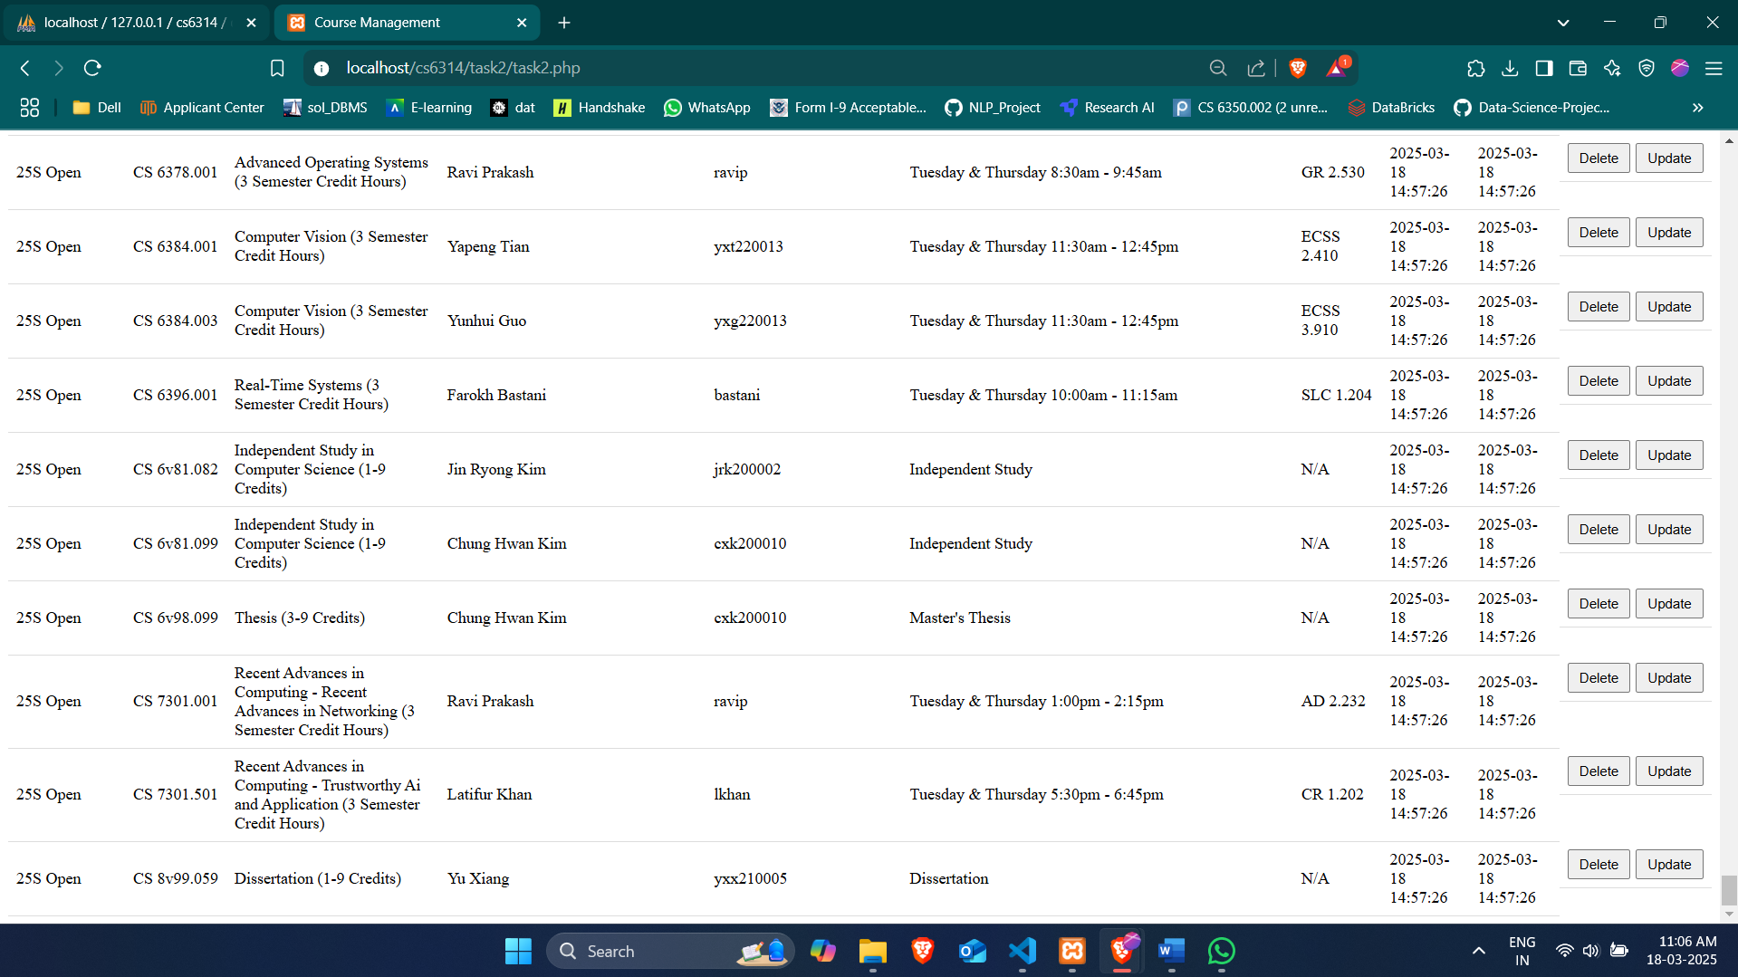

## Test Cases

The script includes JavaScript functions in testcases.js that automate the addition, update, and deletion of predefined courses.

## Functionality

Adding a New Course

Users can add a new course by filling out the form at the top of the page and clicking "Add Course".

I tried to add a course here using the form, schedule and location fields can be empty and others need to have data in order to submit the form.

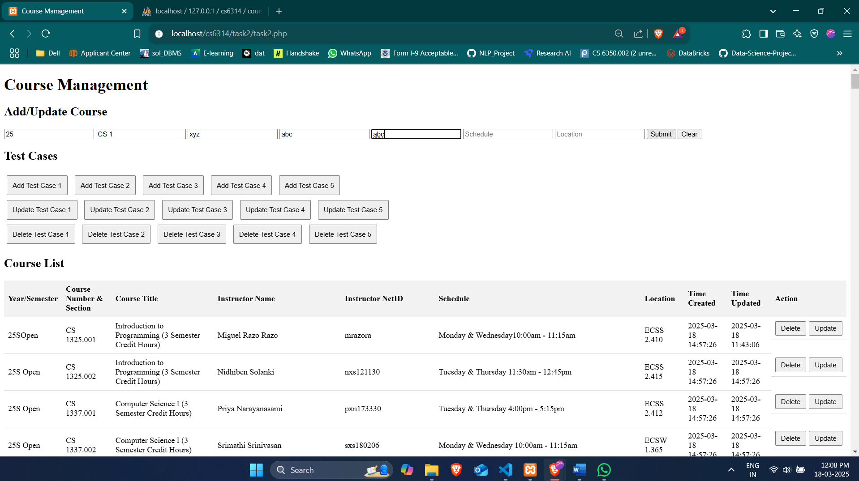

Here is the result after adding the above course to the form.

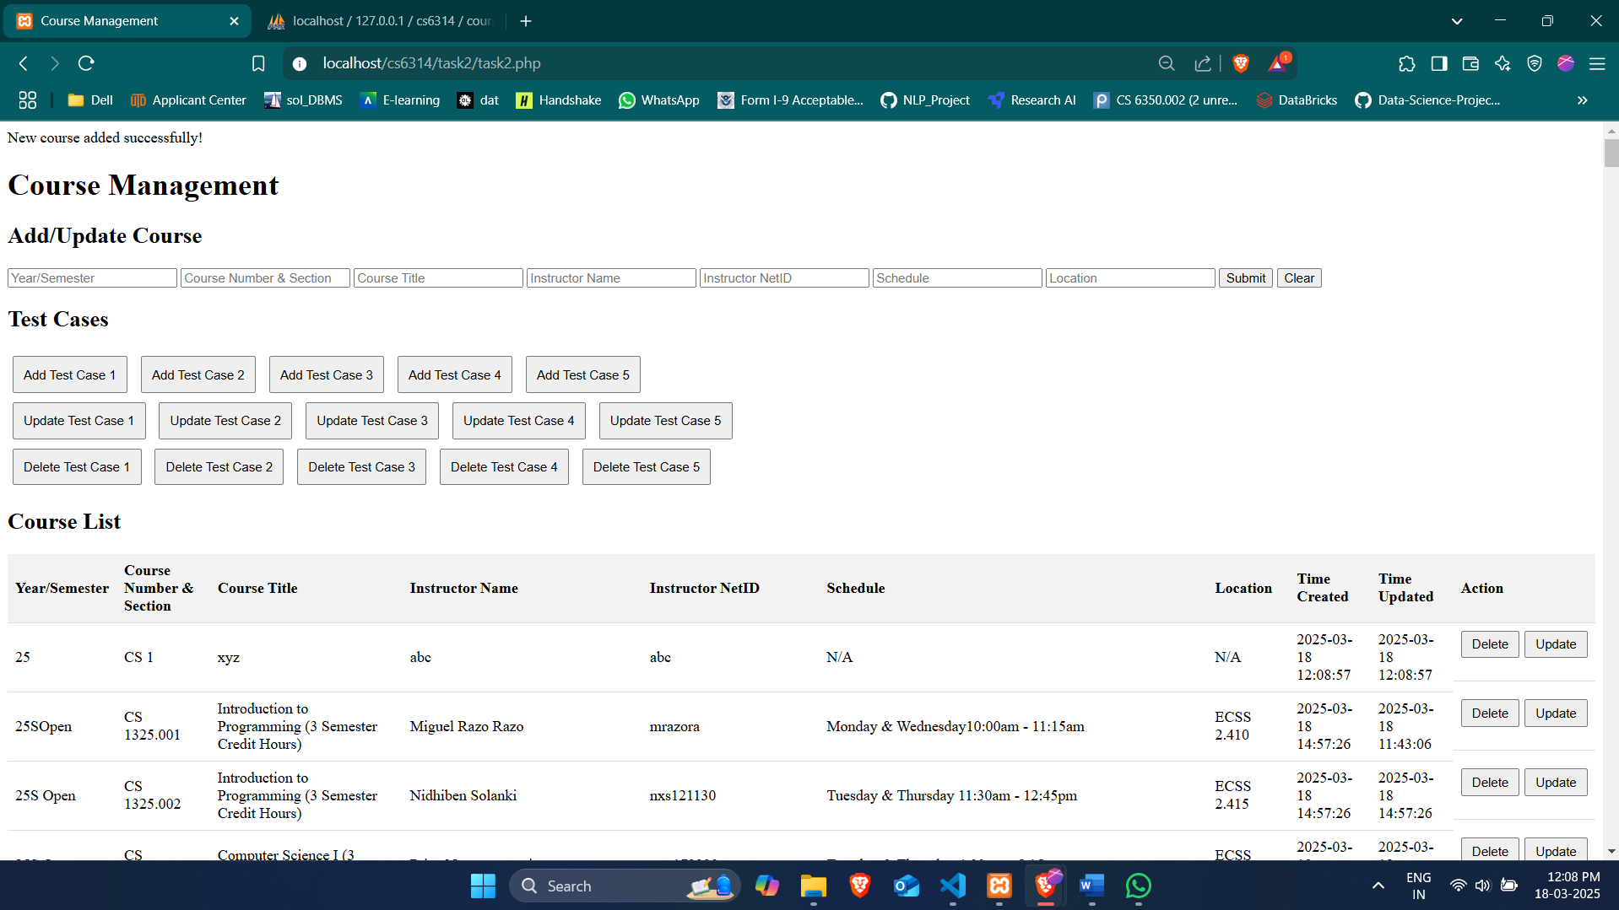

You can see the above change in the database also.

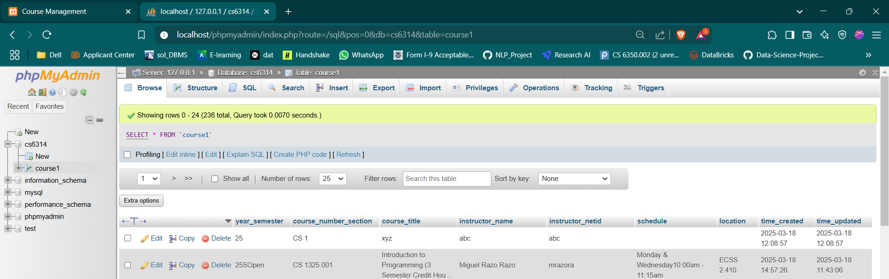

## Updating an Existing Course

Users can update a course by clicking the "Update" button next to a course entry, which submits a form with the updated information.

When update in actions column is clicked we can see that row in form above.

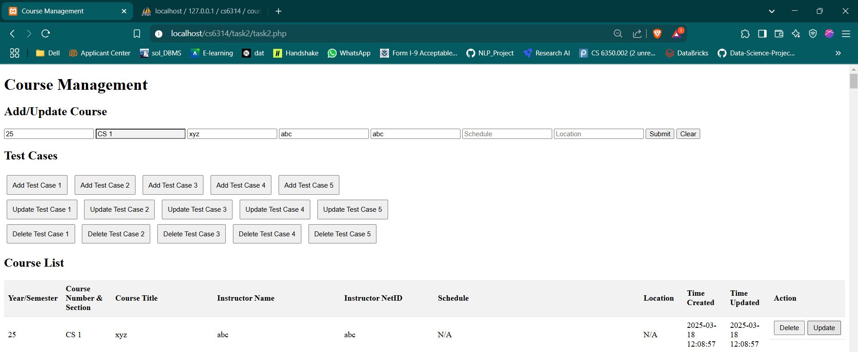

And then we can do necessay edits and submit.

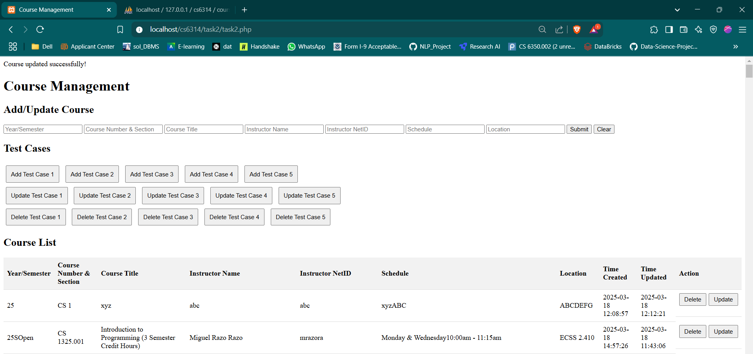

You can see the changes in database also.

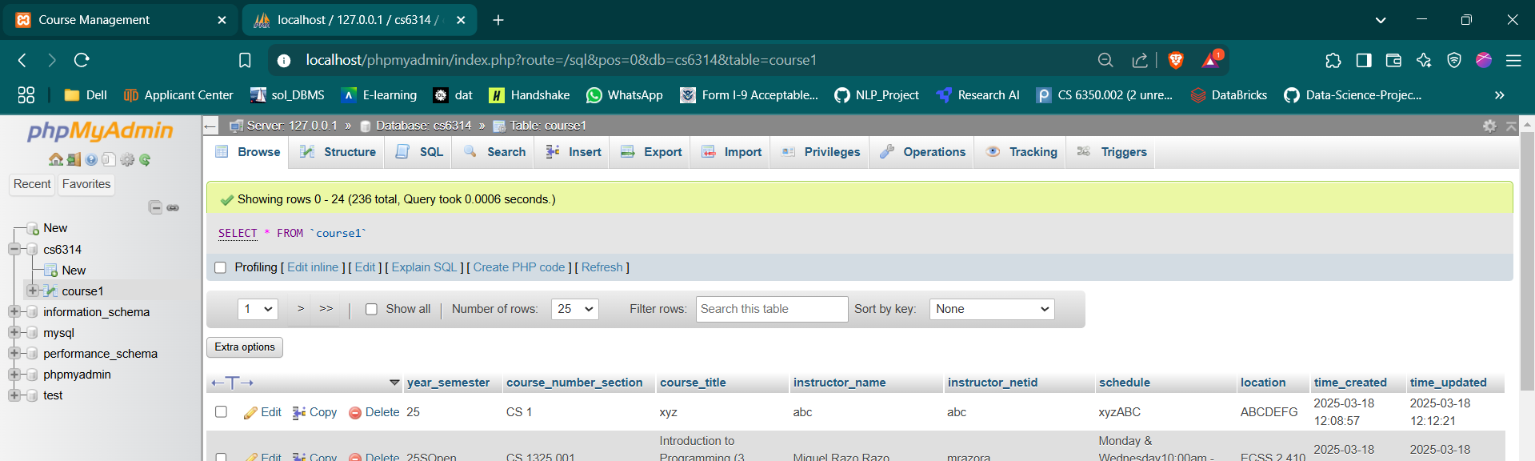

## Deleting a Course

Users can delete a course by clicking the "Delete" button next to a course entry, which submits a form to delete the course.

Before deletion

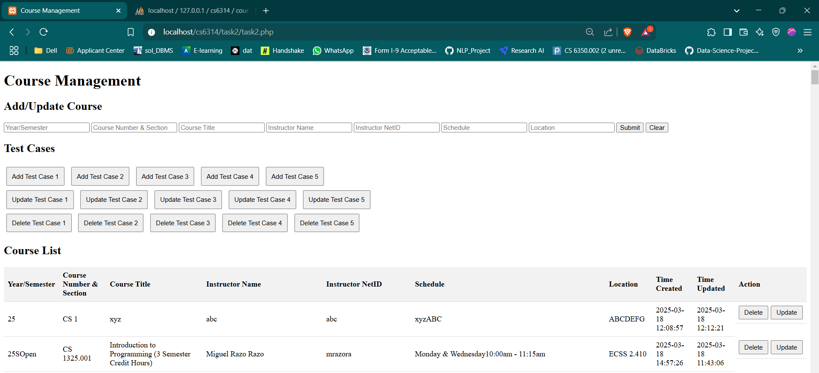

After deletion of course CS 1

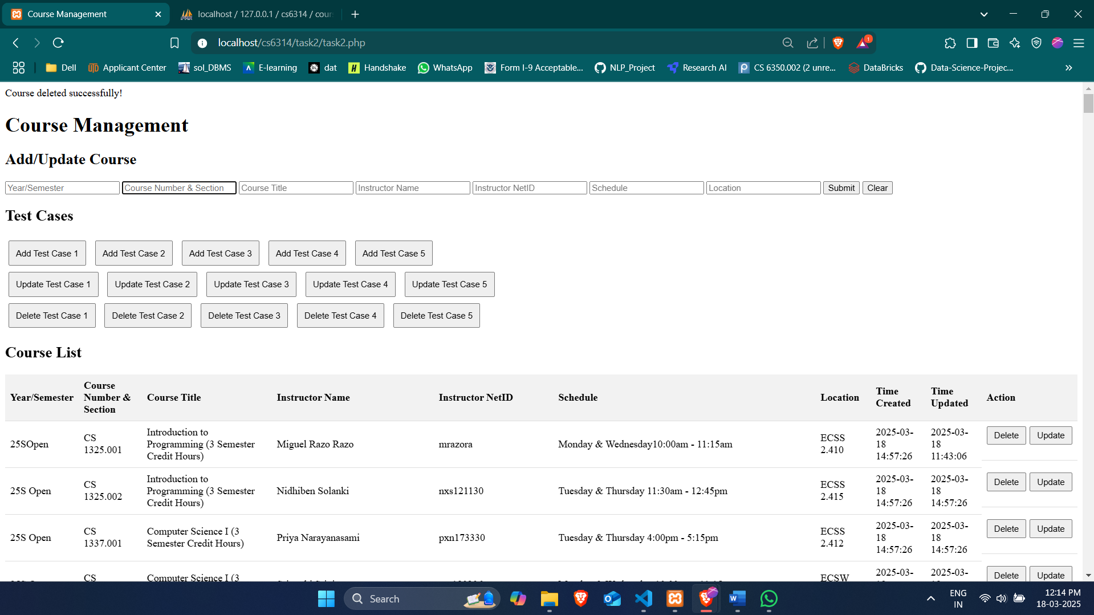

Here is the database update after deletion.

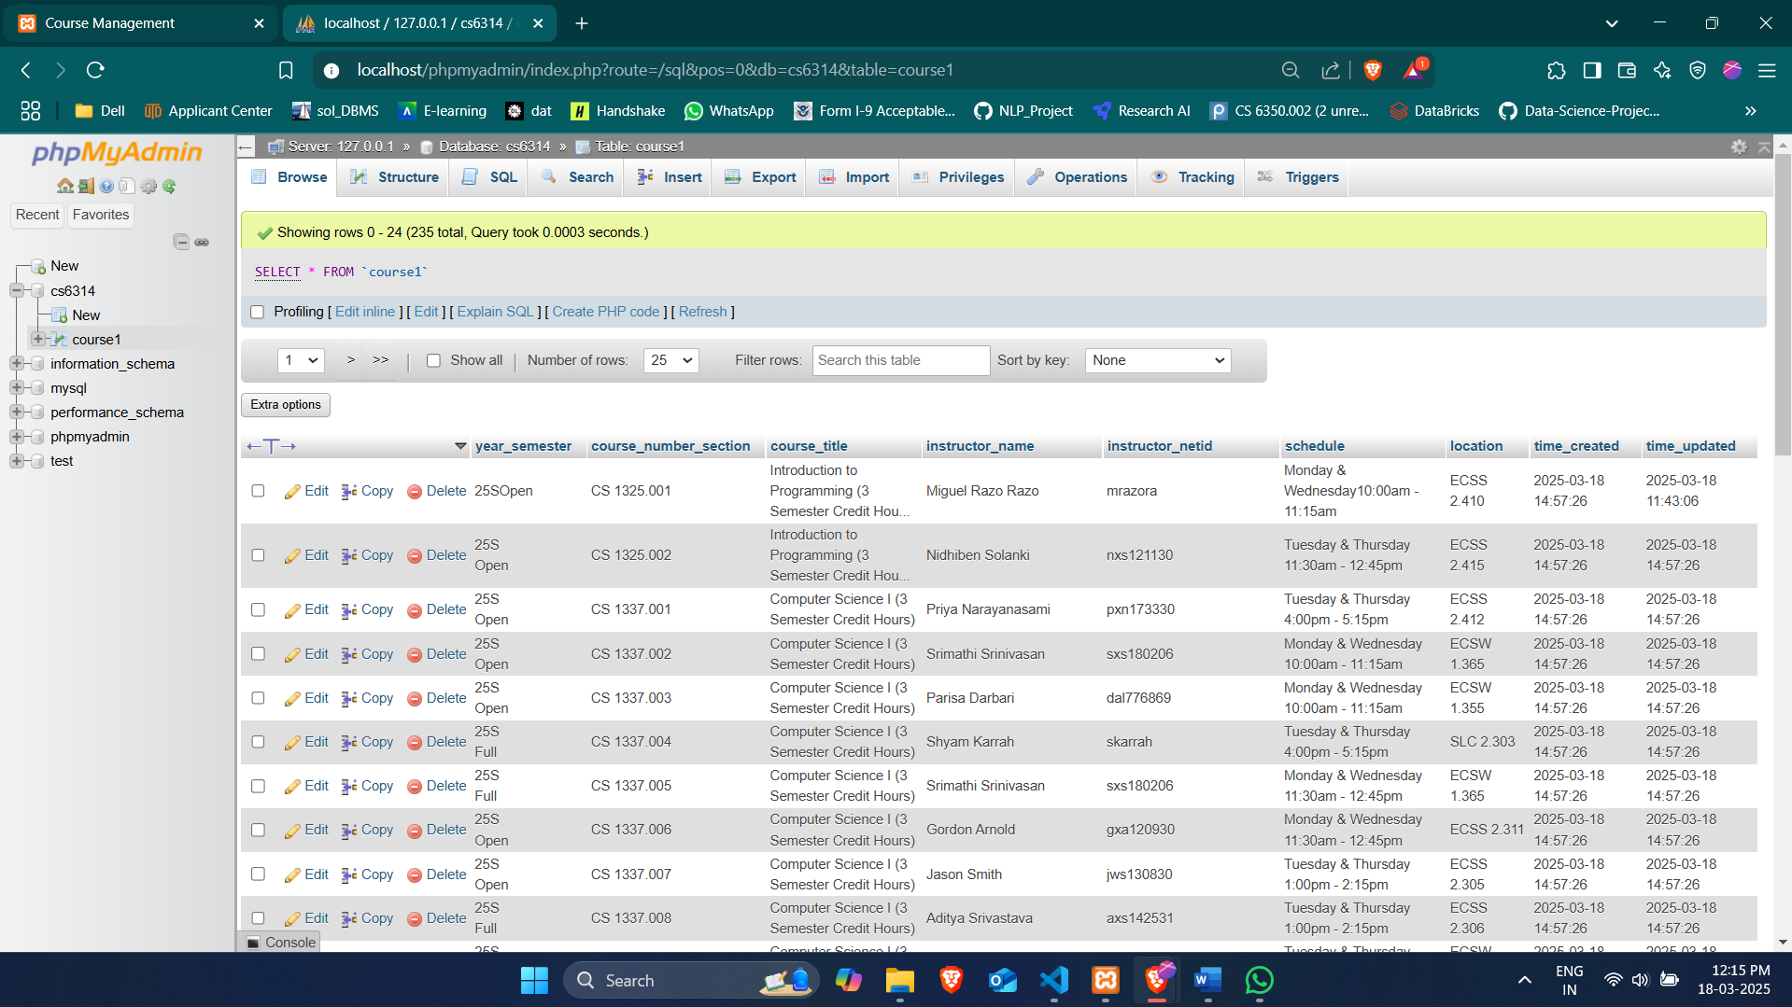

## Test Cases

## Add Test Cases

These functions populate the add course form with predefined test data and submit it.

## addTestCase1()

* Adds a course with:
* Year/Semester: S25
* Course Number & Section: CS1000.001
* Course Title: Introduction to Programming
* Instructor Name: John Doe
* Instructor NetID: jxd123456
* Schedule: MW 10:00 AM - 11:15 AM
* Location: ECSS 2.311

When Add Test Case 1 button is clicked the data comes to the form.

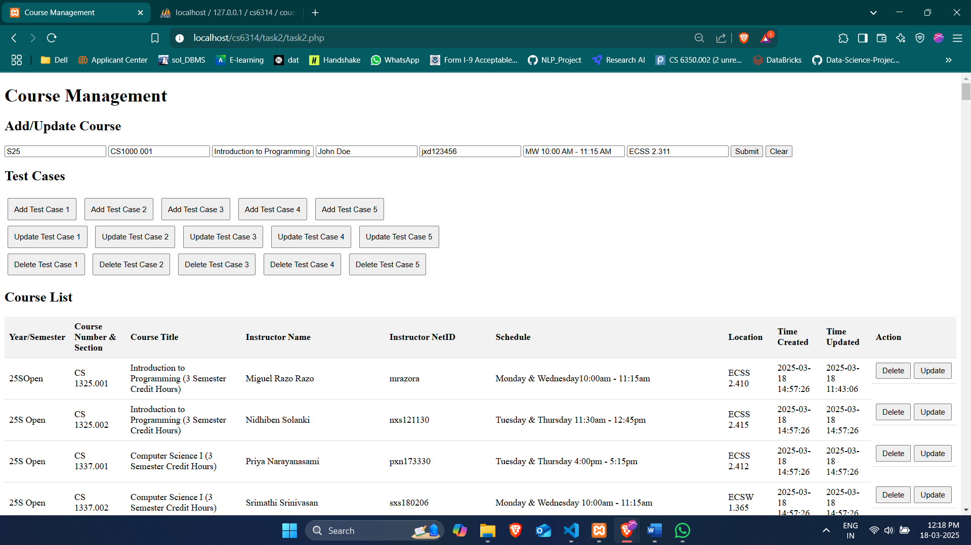

Result after addition.

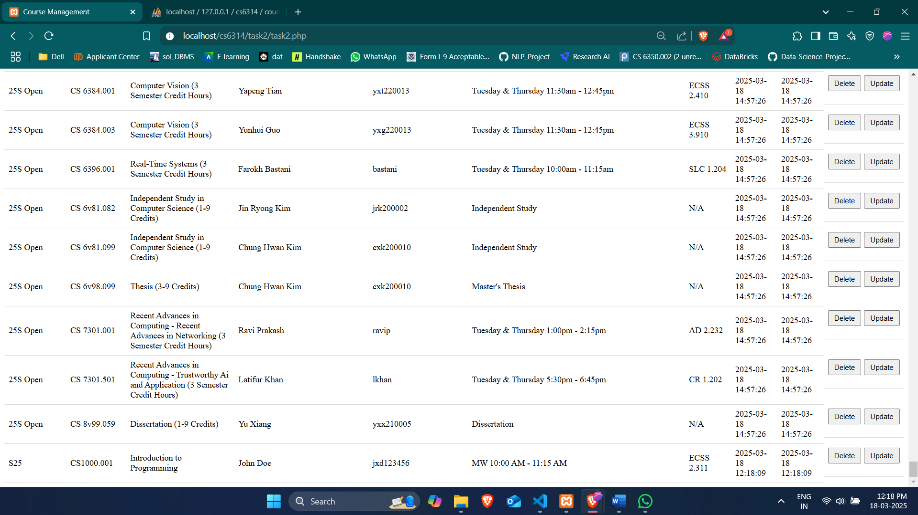

## addTestCase2()

* Adds a course with:
* Year/Semester: S25
* Course Number & Section: CS1001.001
* Course Title: Data Structures
* Instructor Name: Jane Smith
* Instructor NetID: jxs654321
* Schedule: TTH 2:00 PM - 3:15 PM
* Location: ECSS 2.312

When Add Test Case 2 button is clicked the data comes to the form.

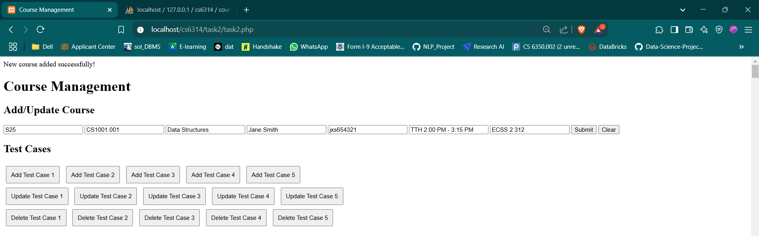

Result after addition.

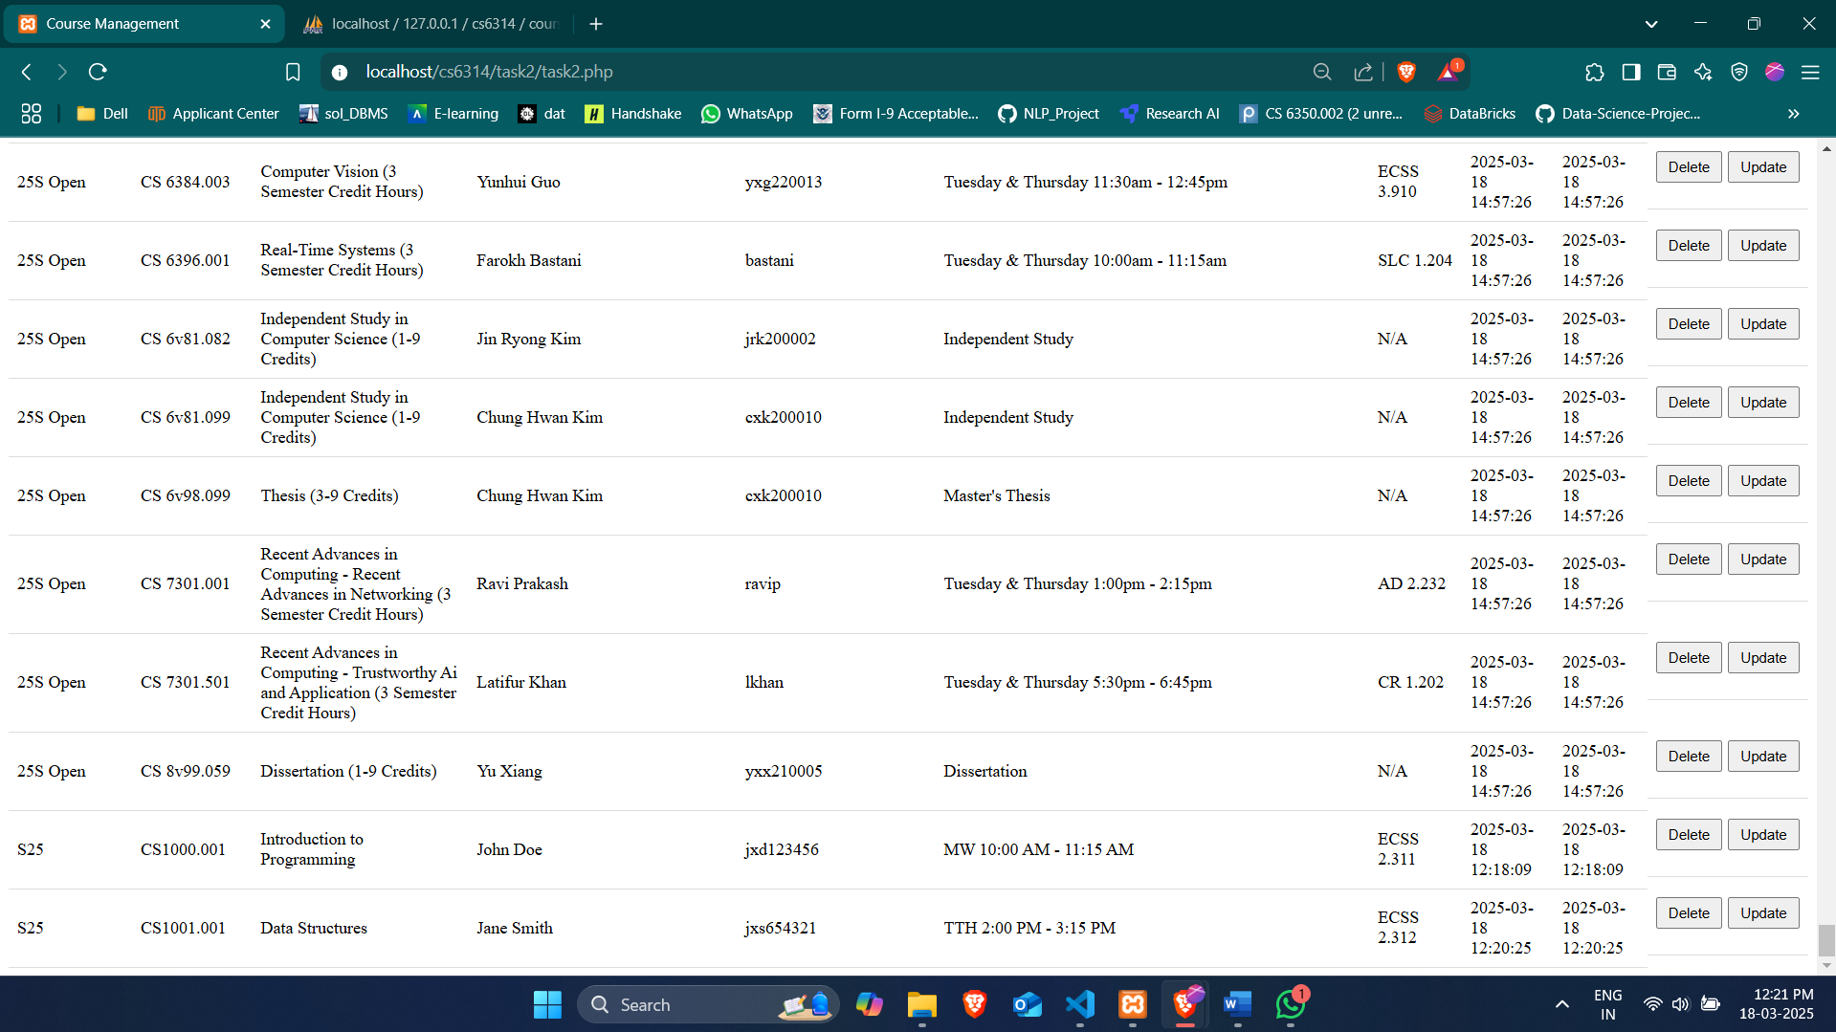

## addTestCase3()

* Adds a course with:
* Year/Semester: S25
* Course Number & Section: CS1002.001
* Course Title: Algorithms
* Instructor Name: Alice Johnson
* Instructor NetID: ajx123456
* Schedule: MWF 1:00 PM - 2:15 PM
* Location: ECSS 2.313

When Add Test Case 3 button is clicked the data comes to the form.

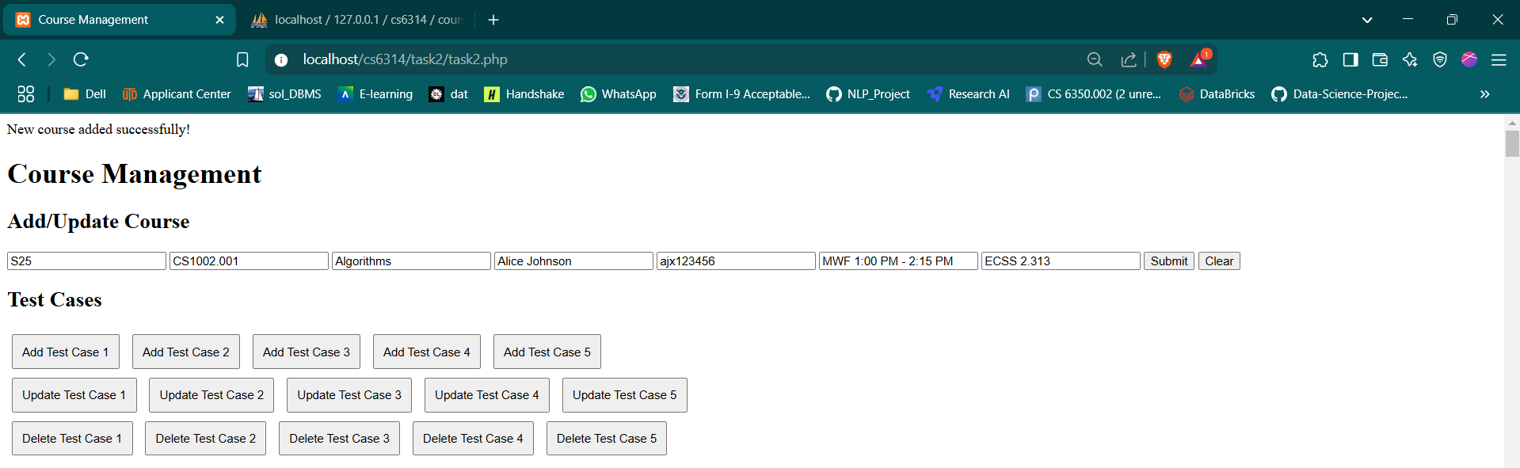

Result

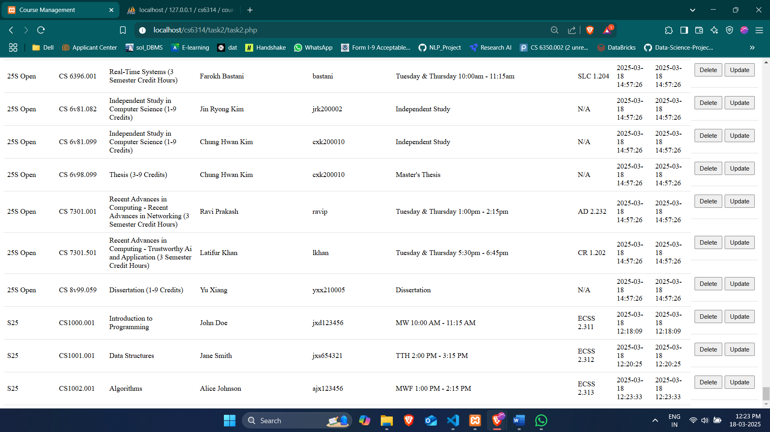

## addTestCase4()

* Adds a course with:
* Year/Semester: S25
* Course Number & Section: CS1003.001
* Course Title: Database Systems
* Instructor Name: Bob Brown
* Instructor NetID: bbx654321
* Schedule: TTH 10:00 AM - 11:15 AM
* Location: ECSS 2.314

When Add Test Case 4 button is clicked the data comes to the form.

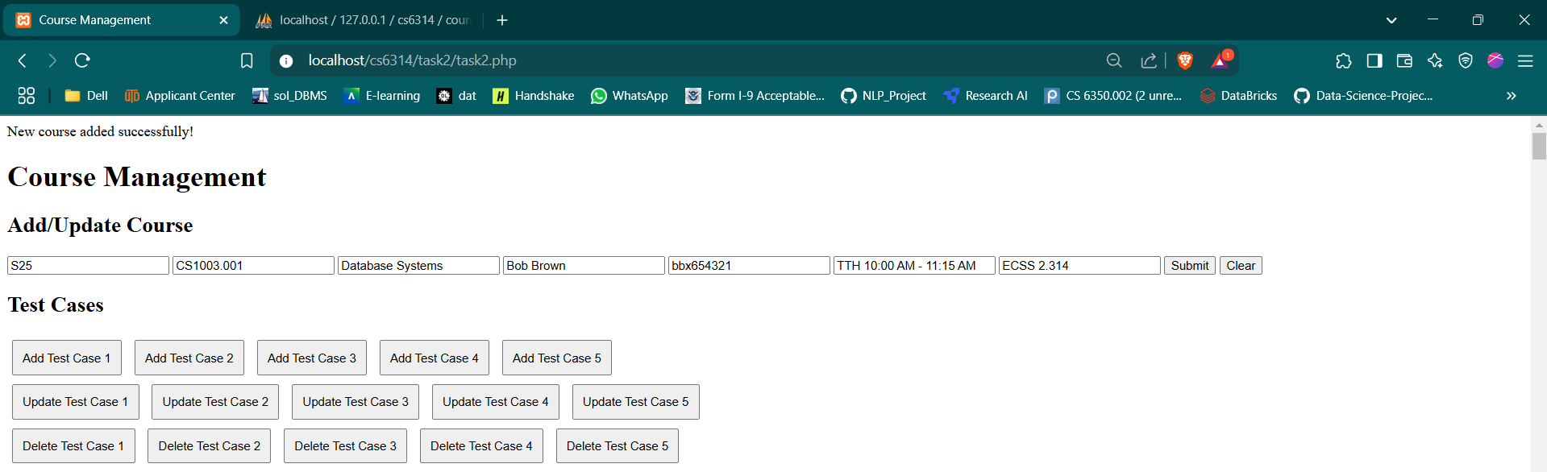

Result

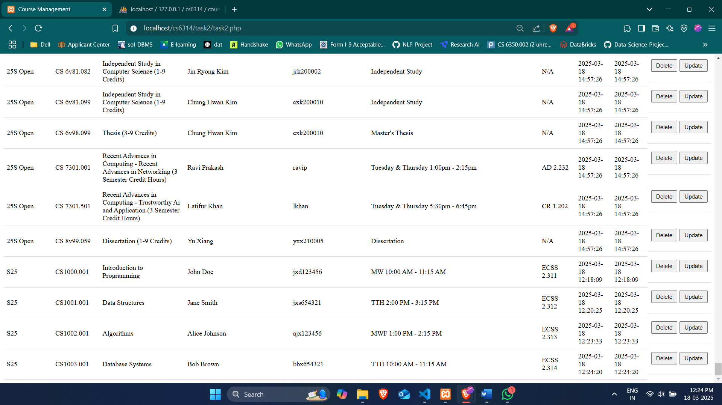

## addTestCase5()

Adds a course with:

* Year/Semester: S25
* Course Number & Section: CS1004.001
* Course Title: Web Development
* Instructor Name: Charlie Davis
* Instructor NetID: cdx123456
* Schedule: MW 3:00 PM - 4:15 PM
* Location: ECSS 2.315

When Add Test Case 5 button is clicked the data comes to the form.

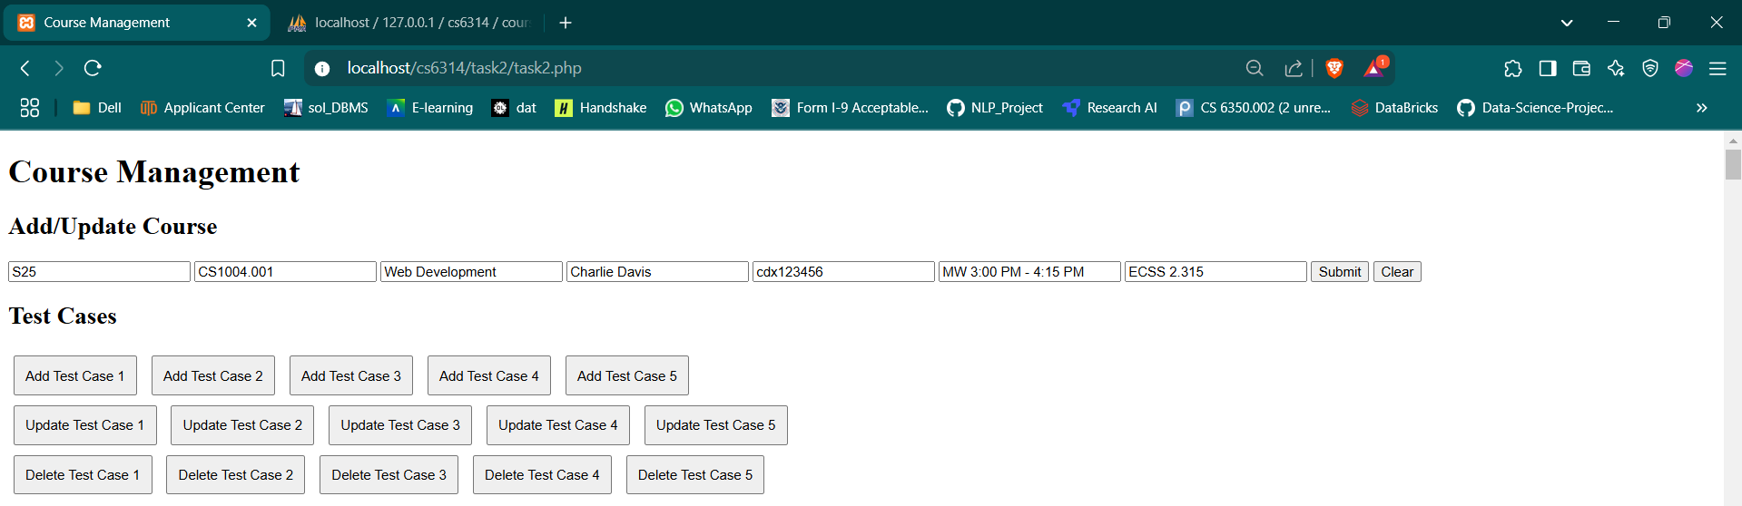

Result

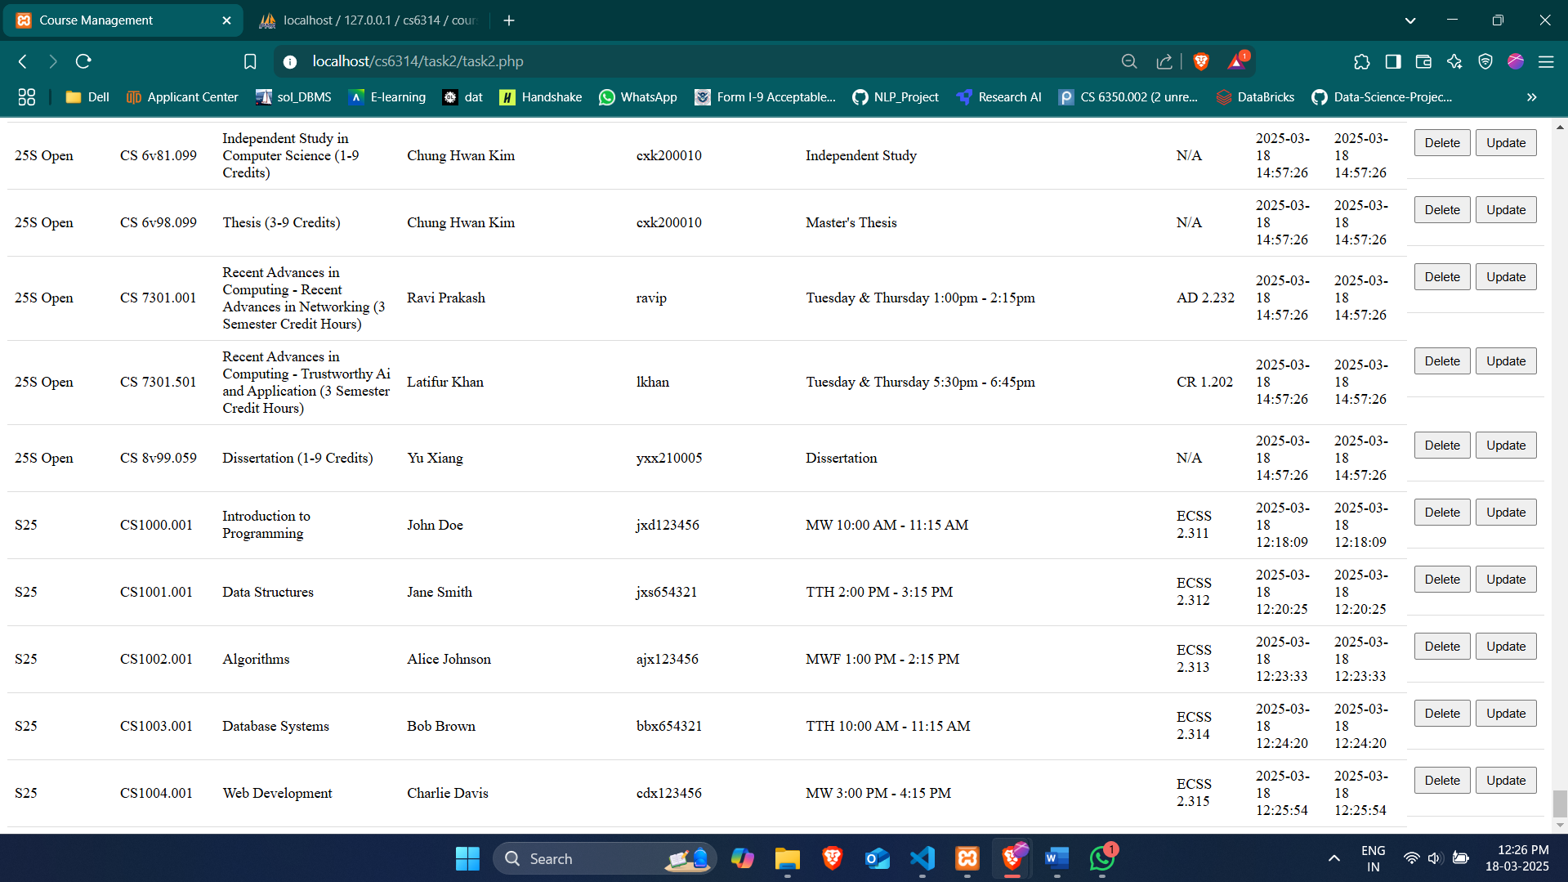

## Update Test Cases

These functions create and submit a form to update specific course information.

## updateTestCase1()

When Update Test Case 1 is clicked the hard codded test case will be updated here.

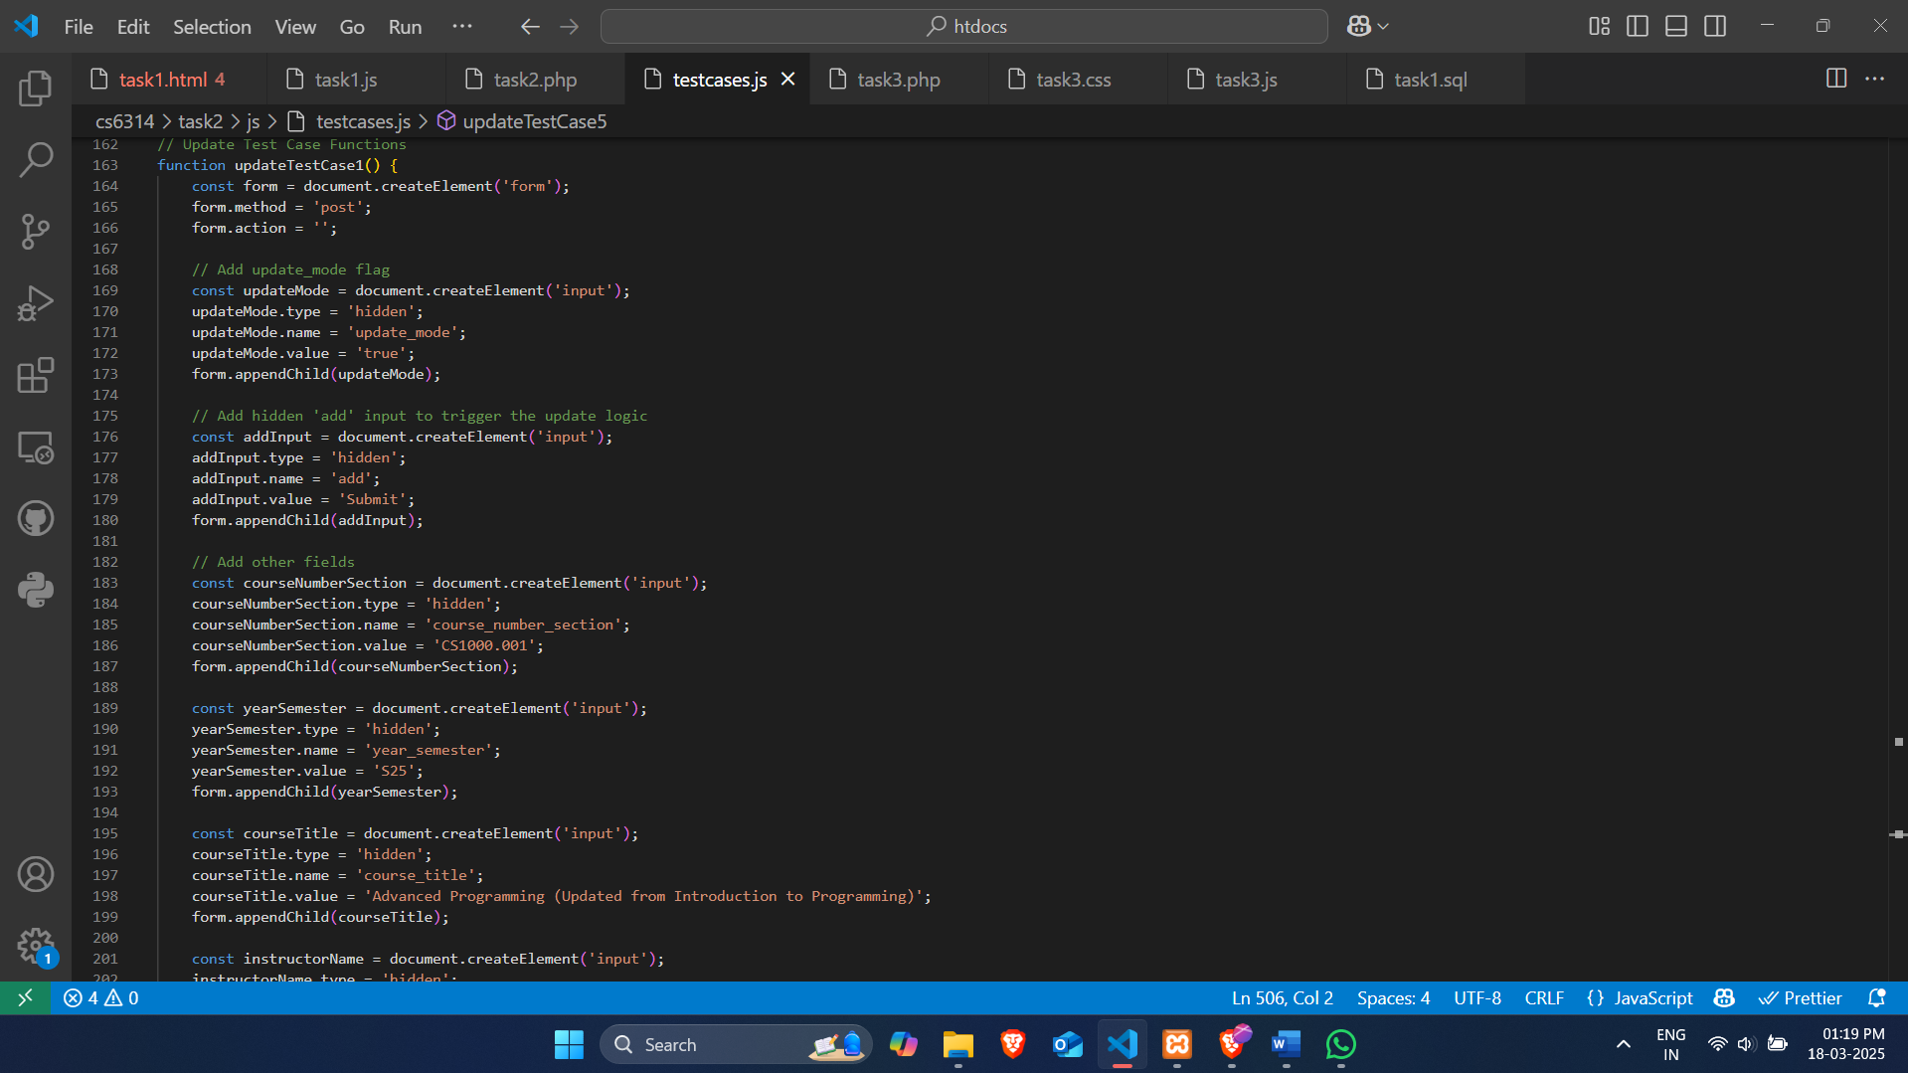

Result

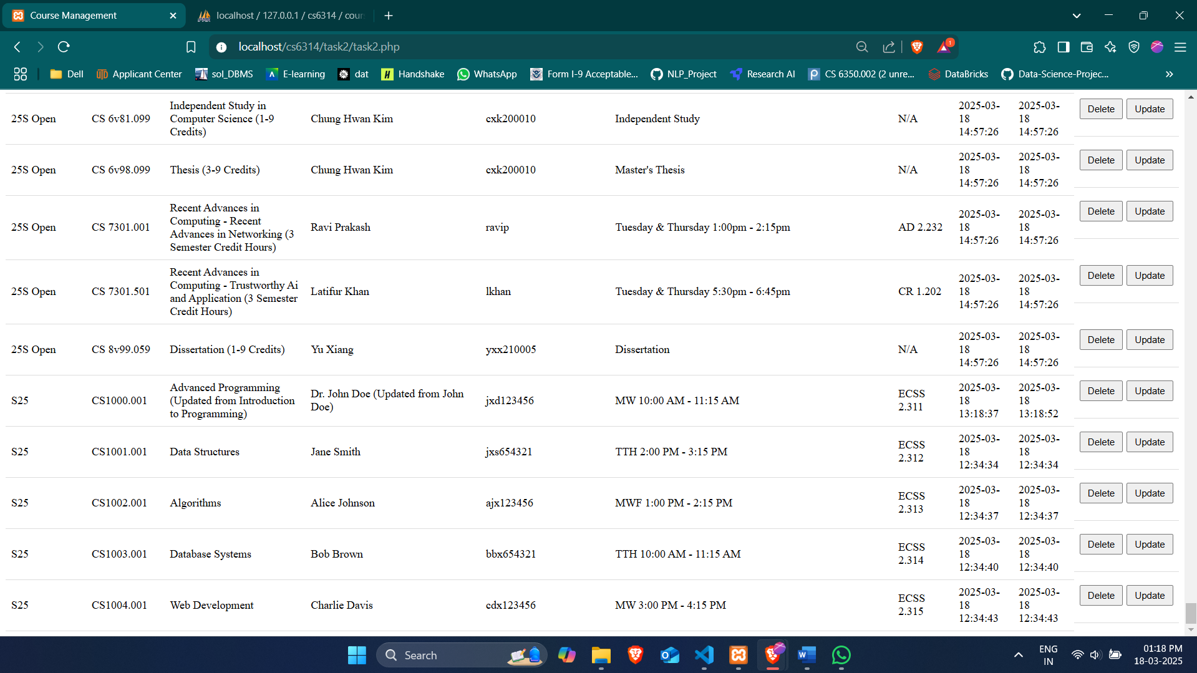

## updateTestCase2()

Updates the course CS1001.001 with new title and schedule

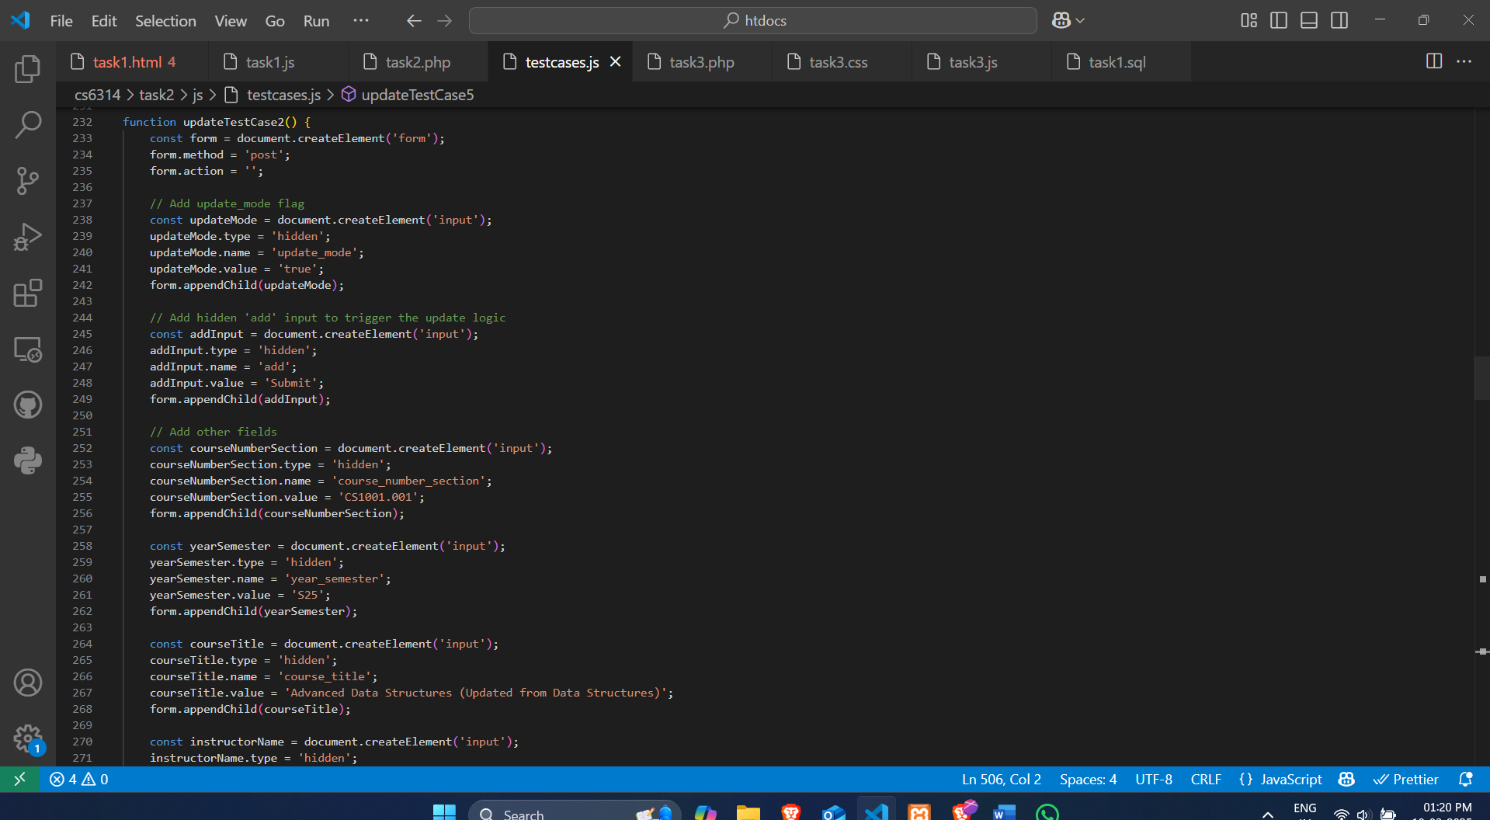

Result

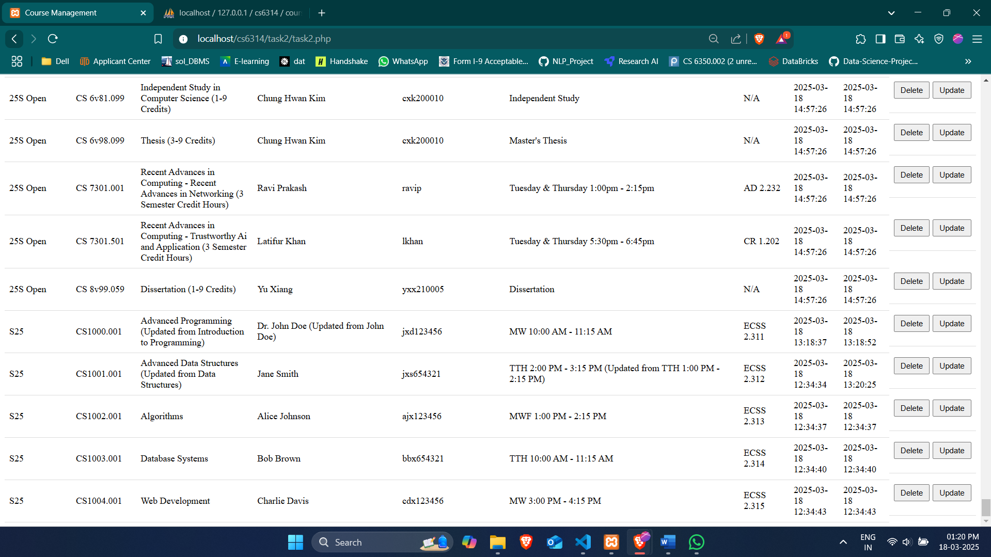

## updateTestCase3()

Updates the course CS1002.001 with new title and instructor NetID

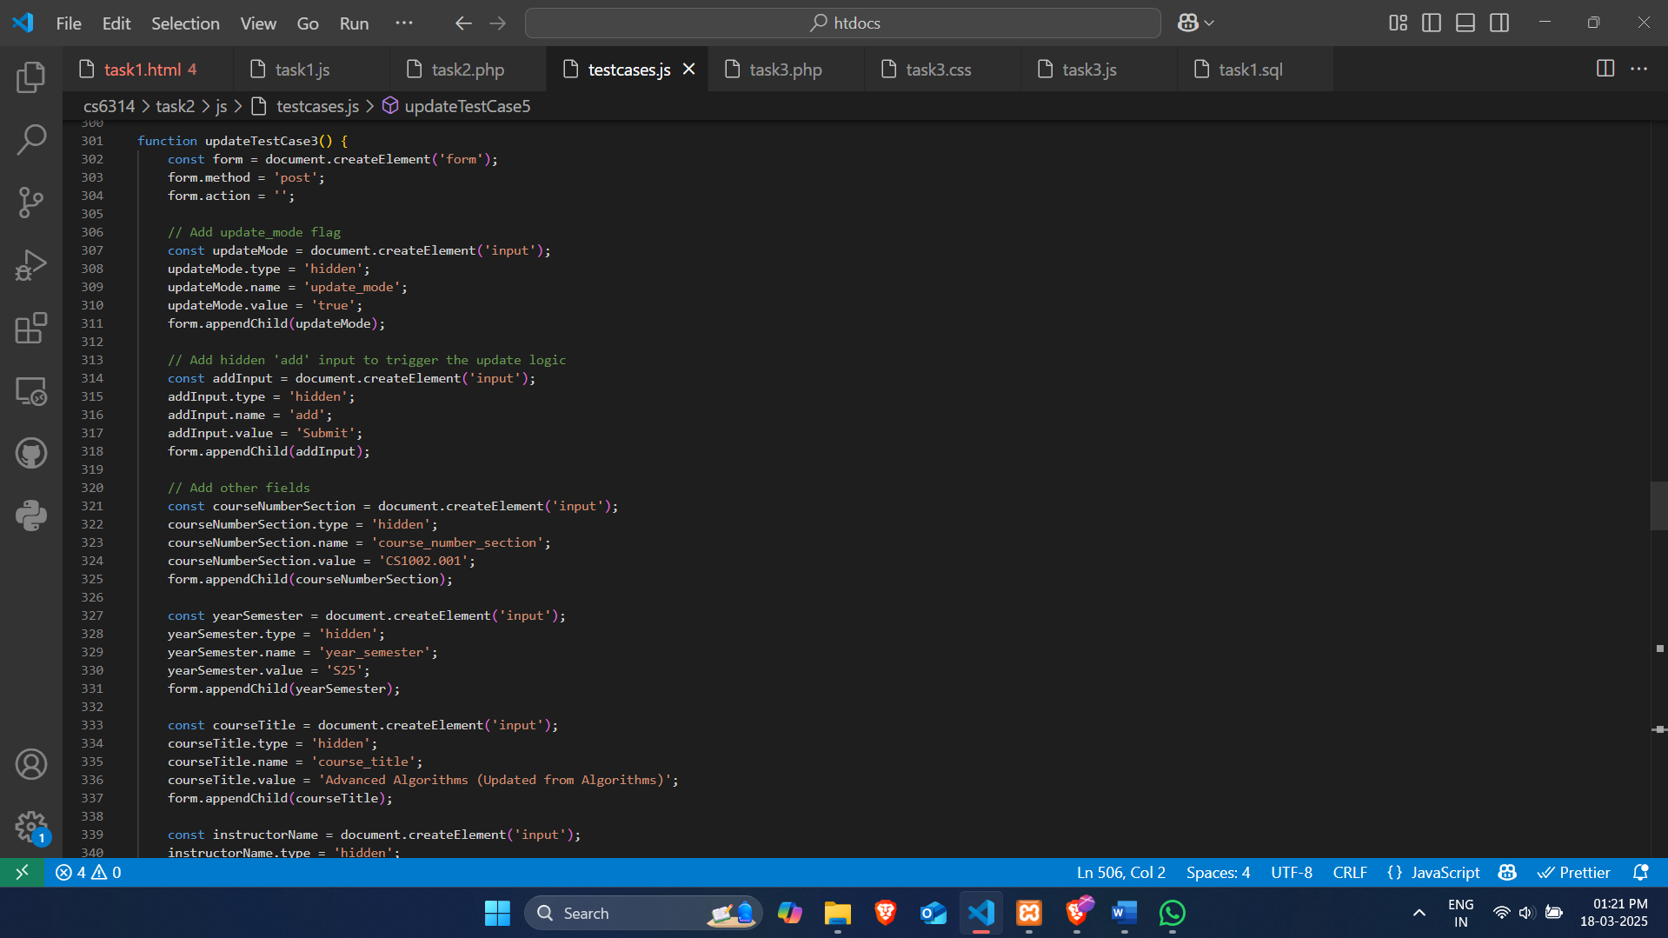

Result

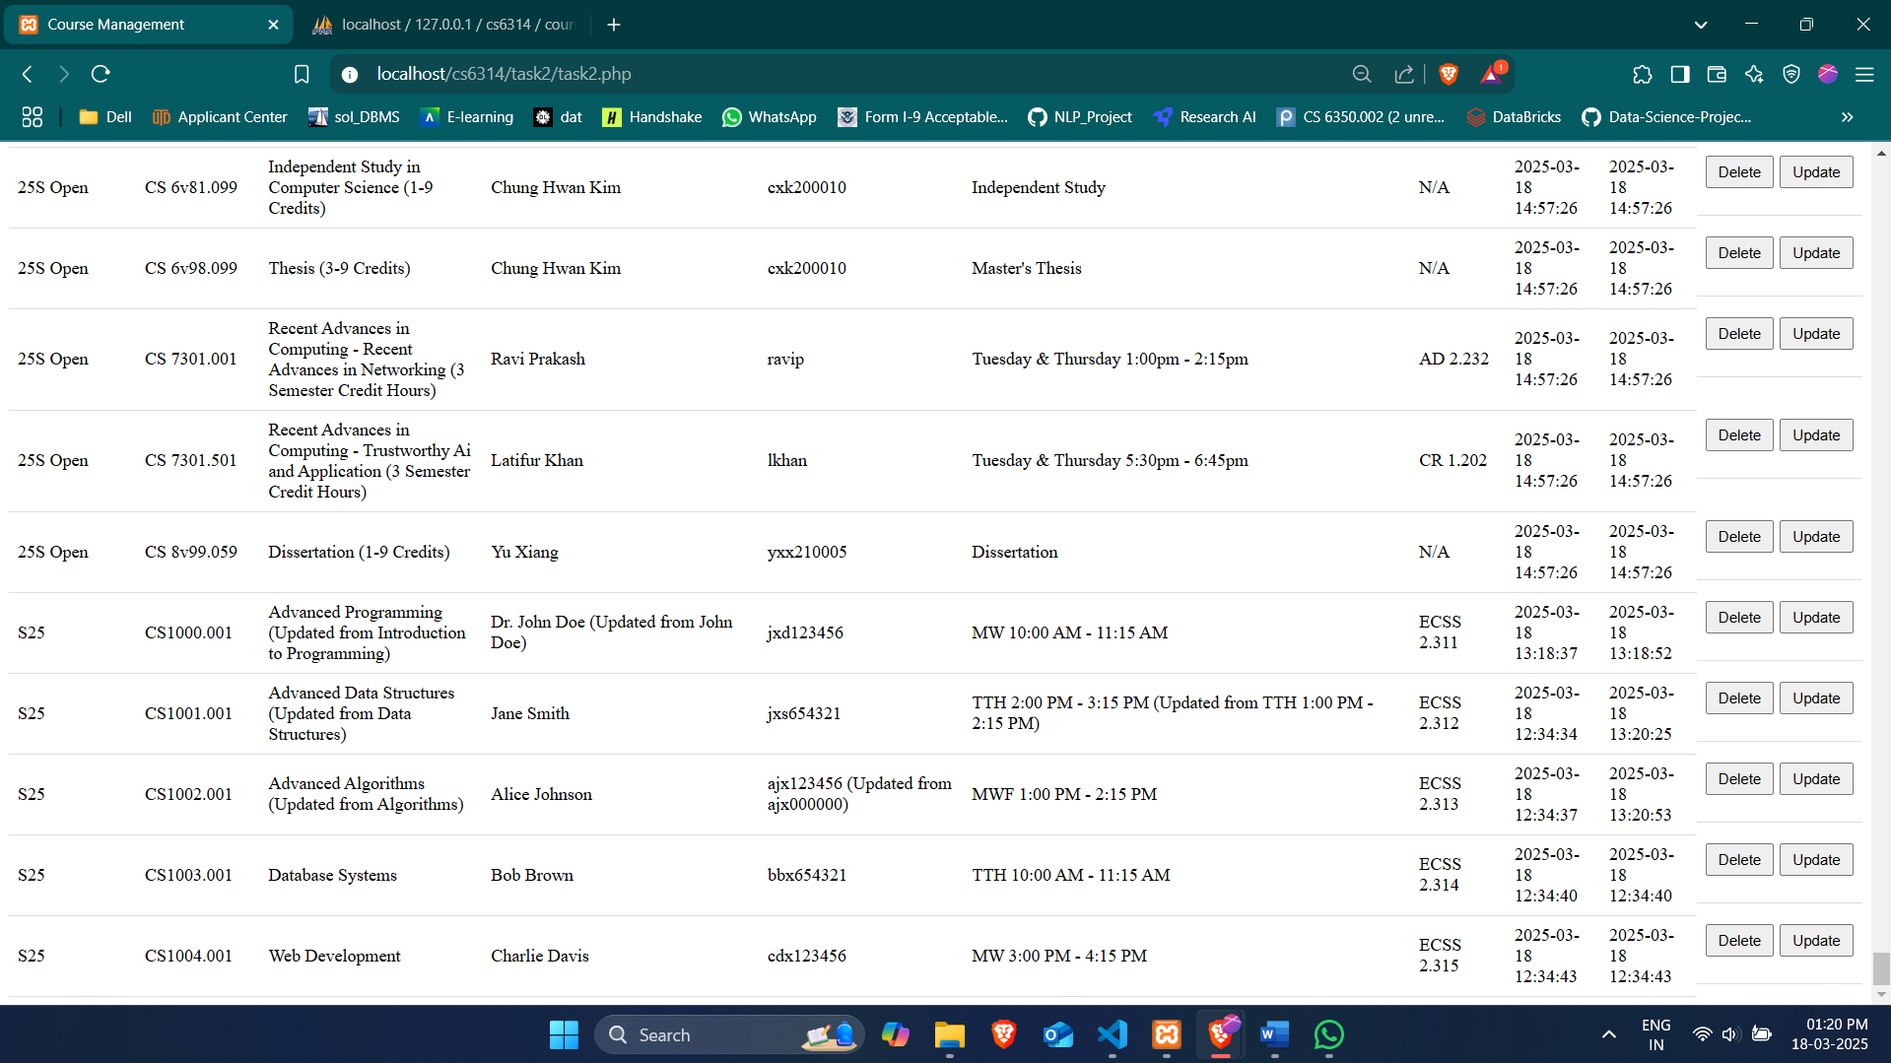

## updateTestCase4()

Updates the course CS1003.001 with new title and location

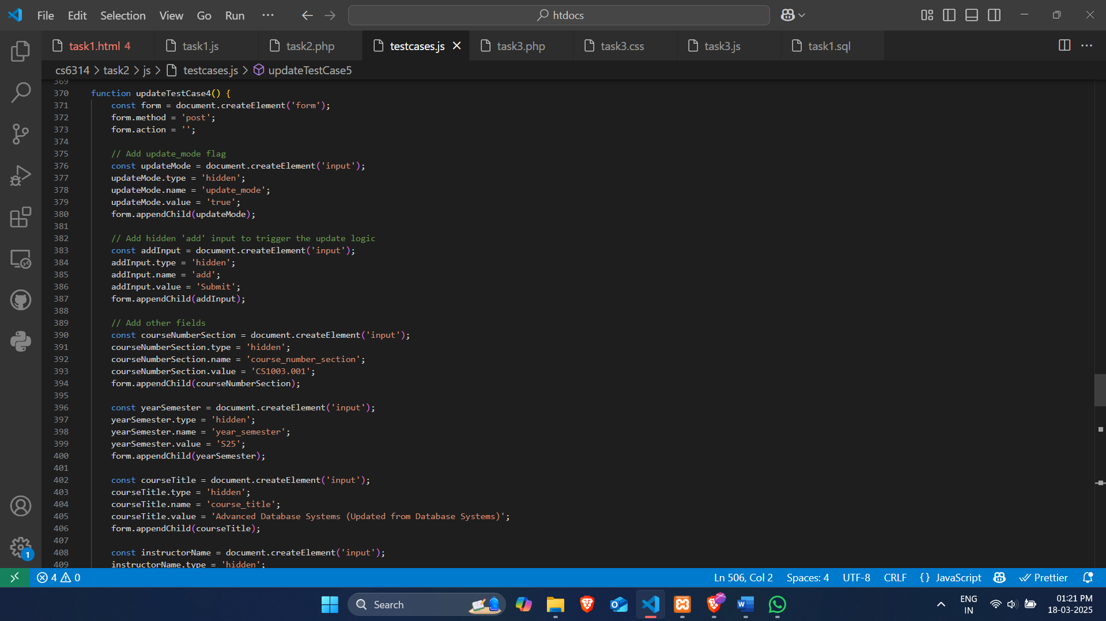

Result

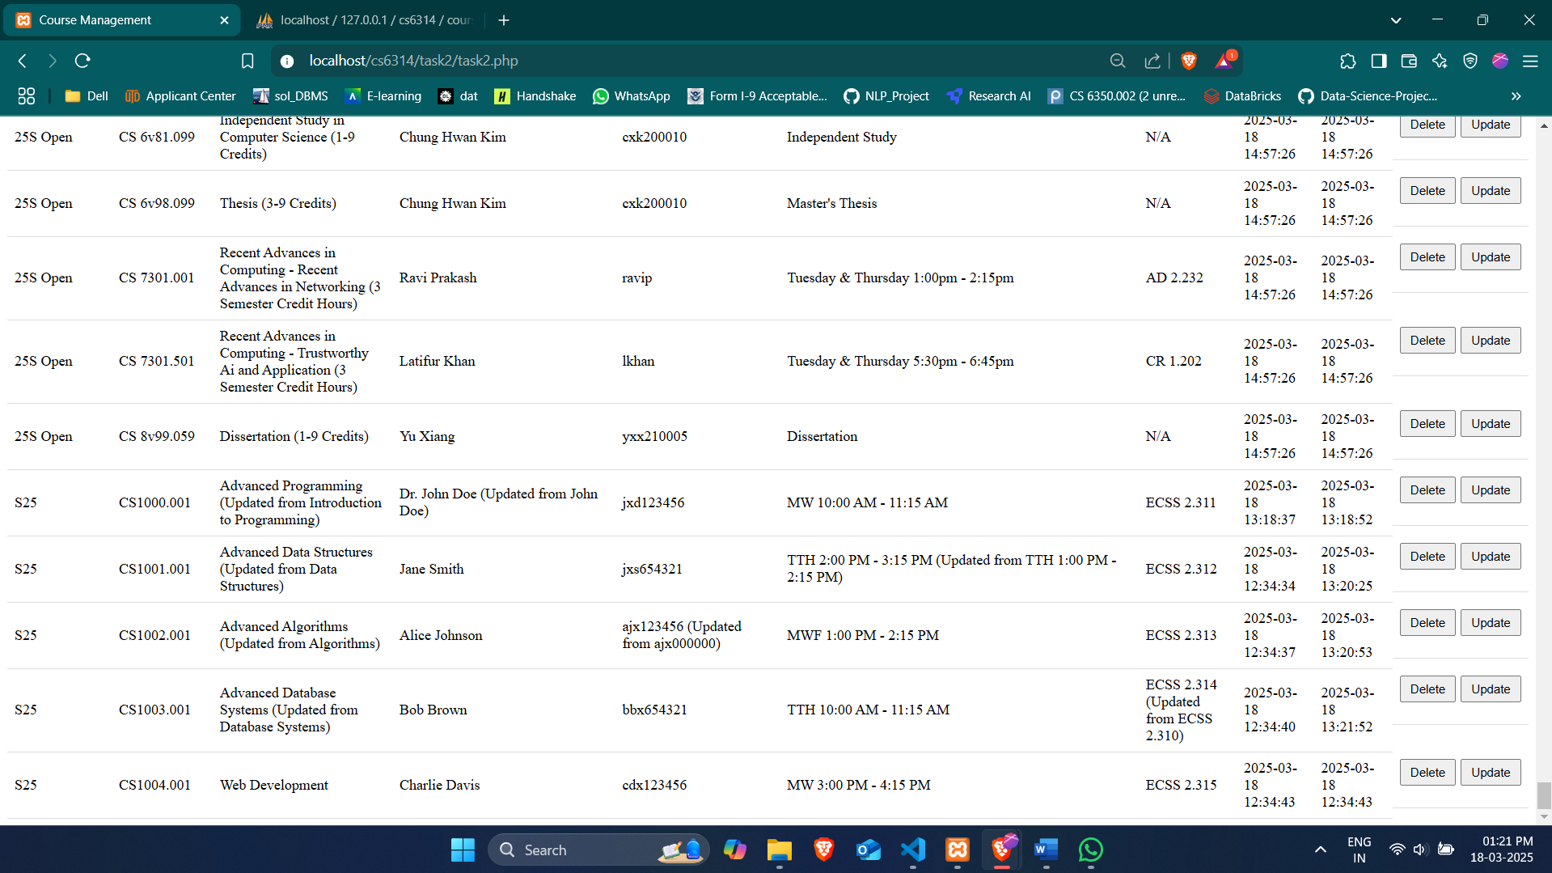

## updateTestCase5()

Updates the course CS1004.001 with new title and instructor name

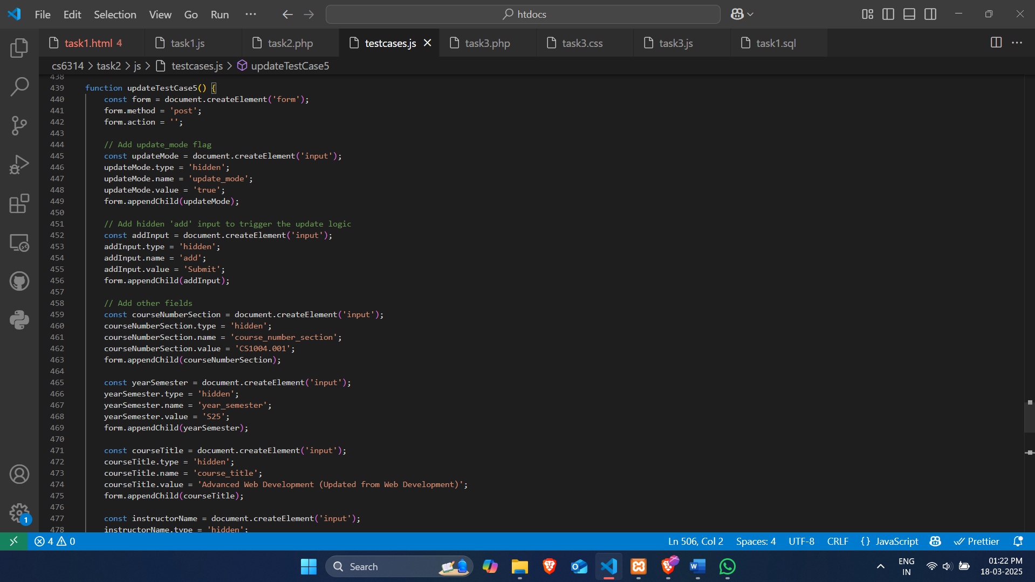

Result

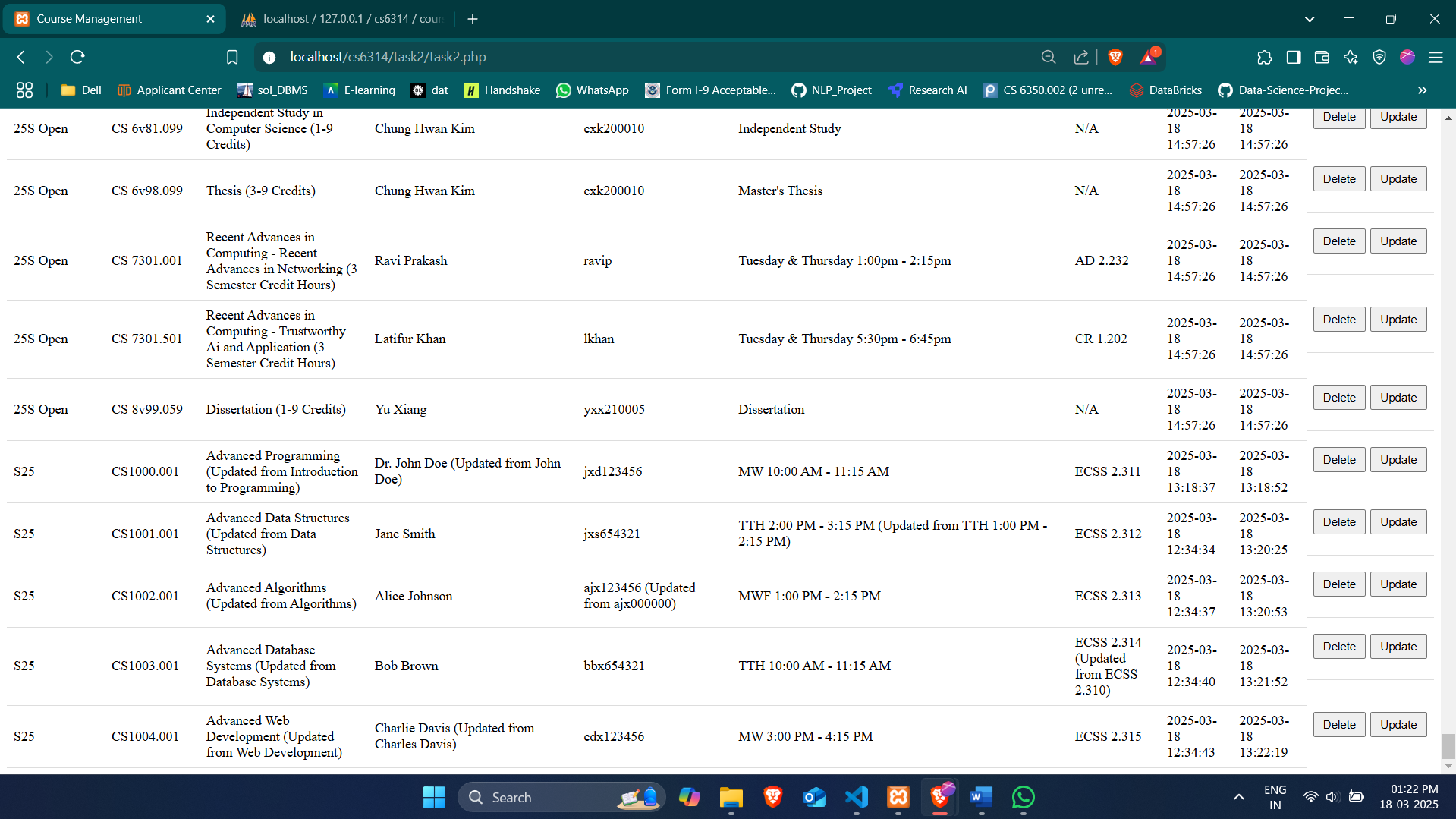

## Delete Test Cases

These functions create and submit a form to delete a specific course by its course number and section.

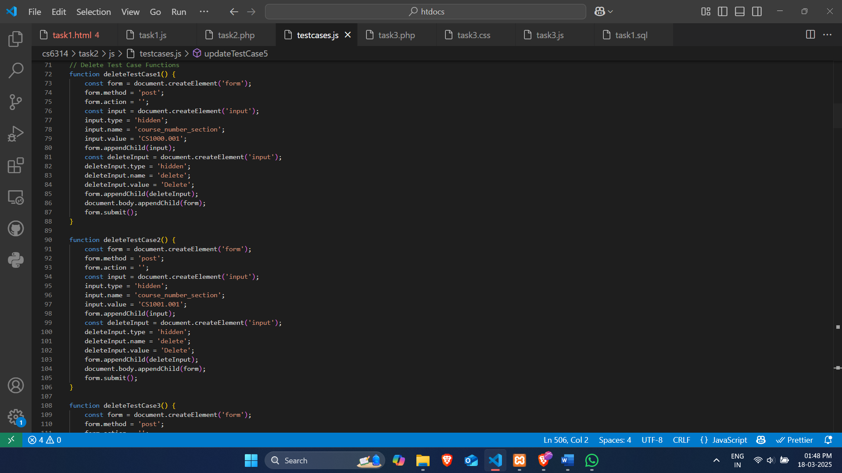

## deleteTestCase1()

Deletes the course with course number section CS1000.001

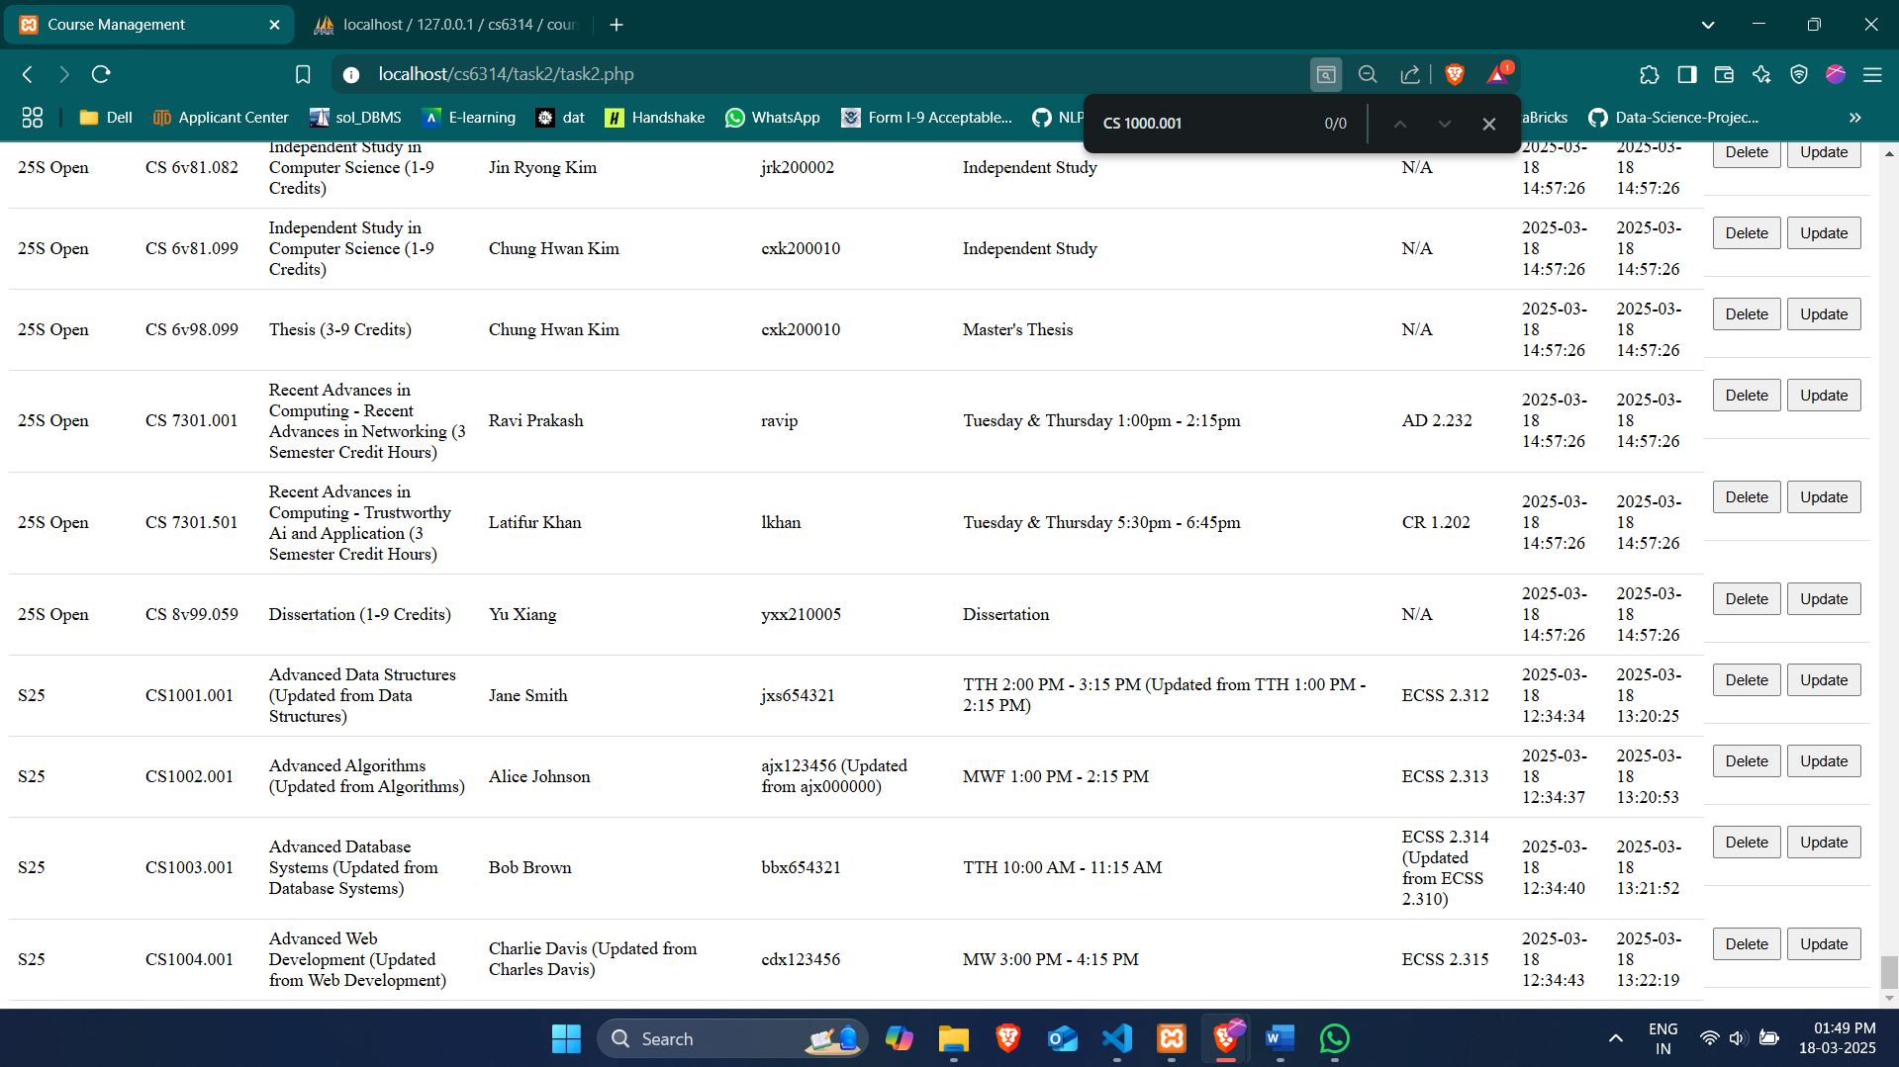

## deleteTestCase2()

Deletes the course with course number section CS1001.001

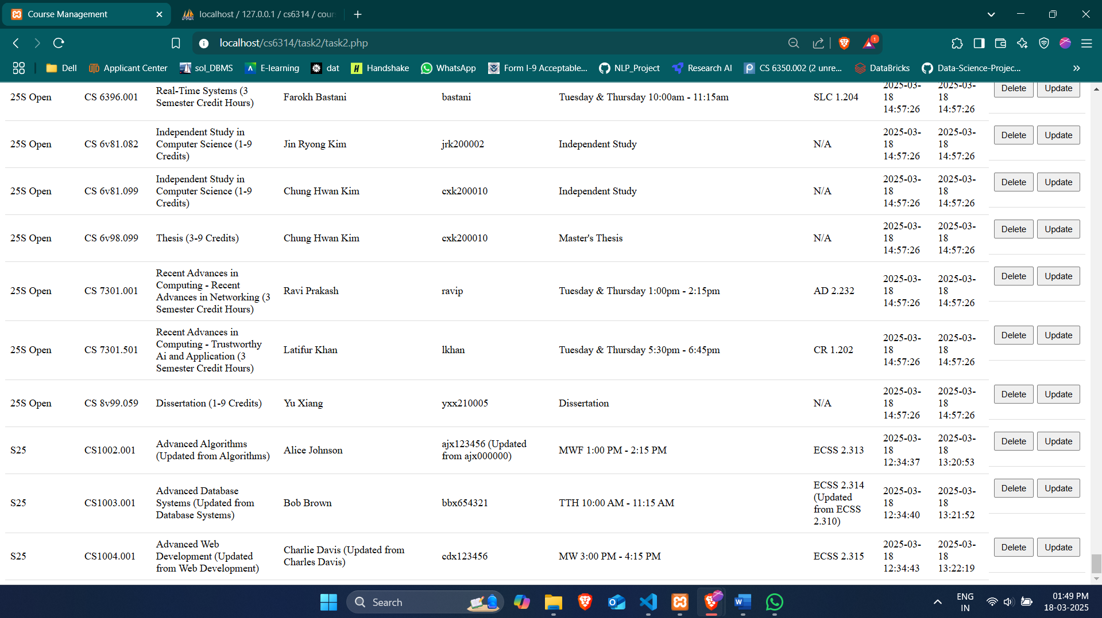

## deleteTestCase3()

Deletes the course with course number section CS1002.001

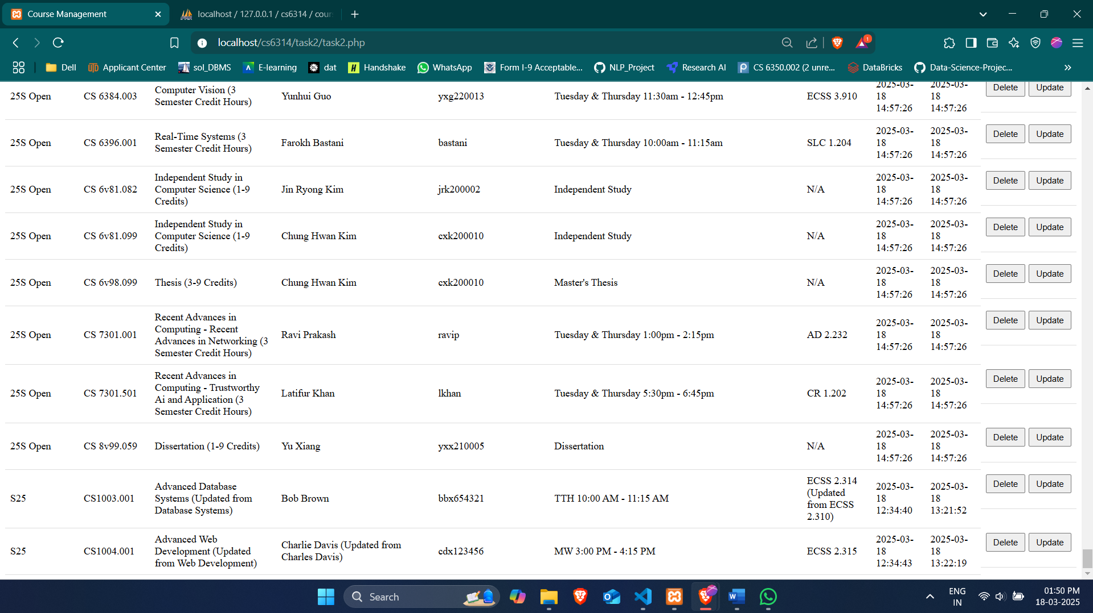

## deleteTestCase4()

Deletes the course with course number section CS1003.001

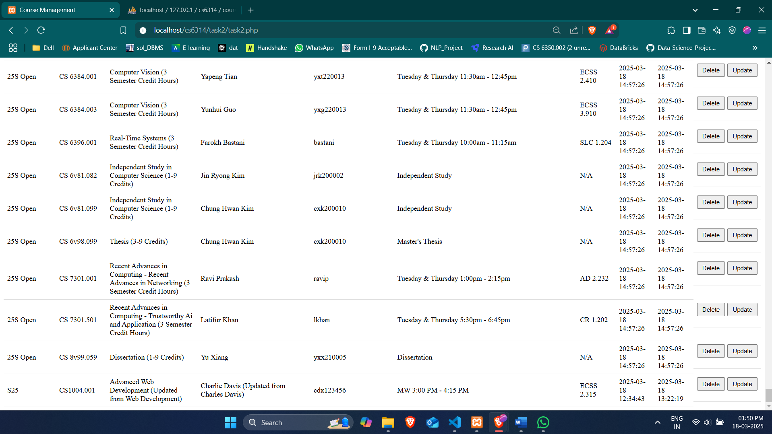

## deleteTestCase5()

Deletes the course with course number section CS1004.001

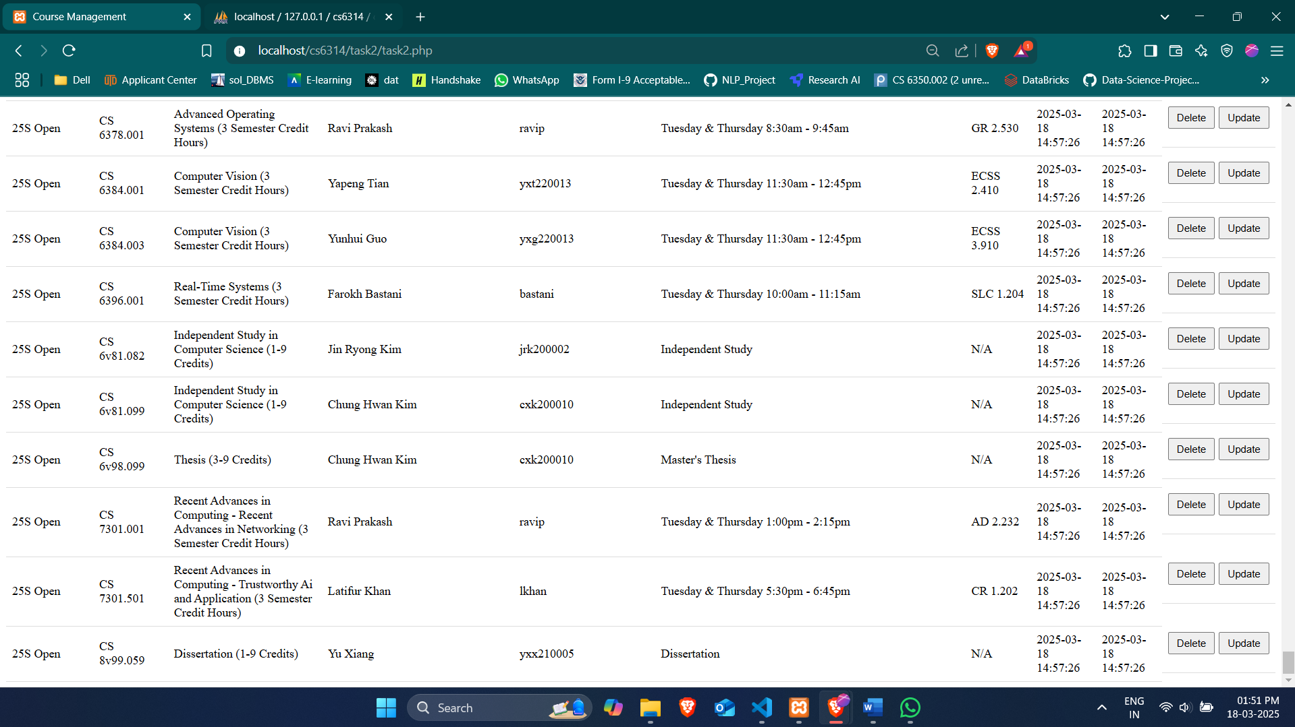**Conclusion**

I successfully implemented Task2 by creating a comprehensive web interface for managing course information. The solution demonstrates proper database connectivity, form handling, and user interface design. The inclusion of automated test cases ensures that all functionality works as expected and provides documentation of the system's behavior.